**Daily Activity Report**

**Submitted By – Gaurav Kulmethe**

**Date 22-01-2024**

**Creating vm and ssh vm**

1. **Resource group**

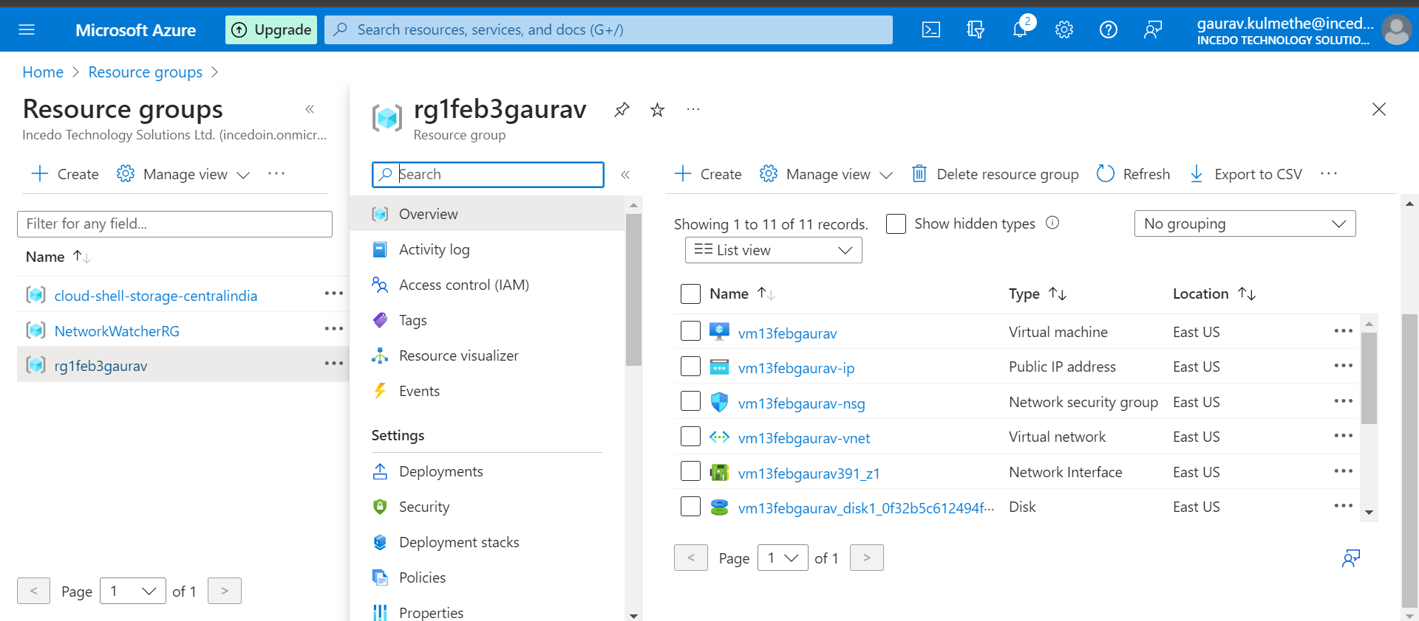

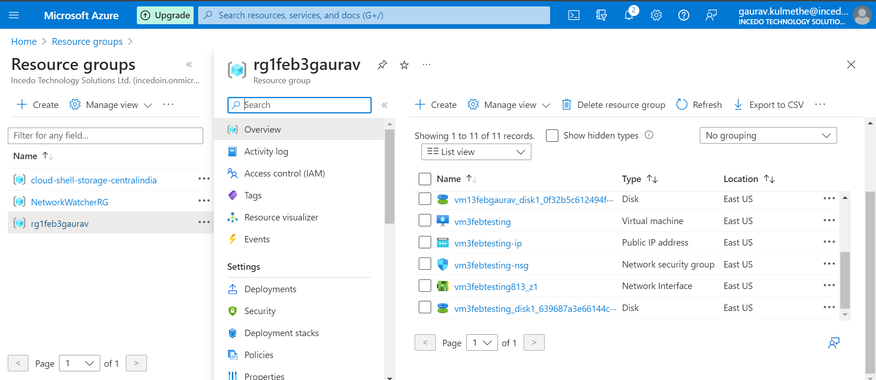

1. **1st vm machine**

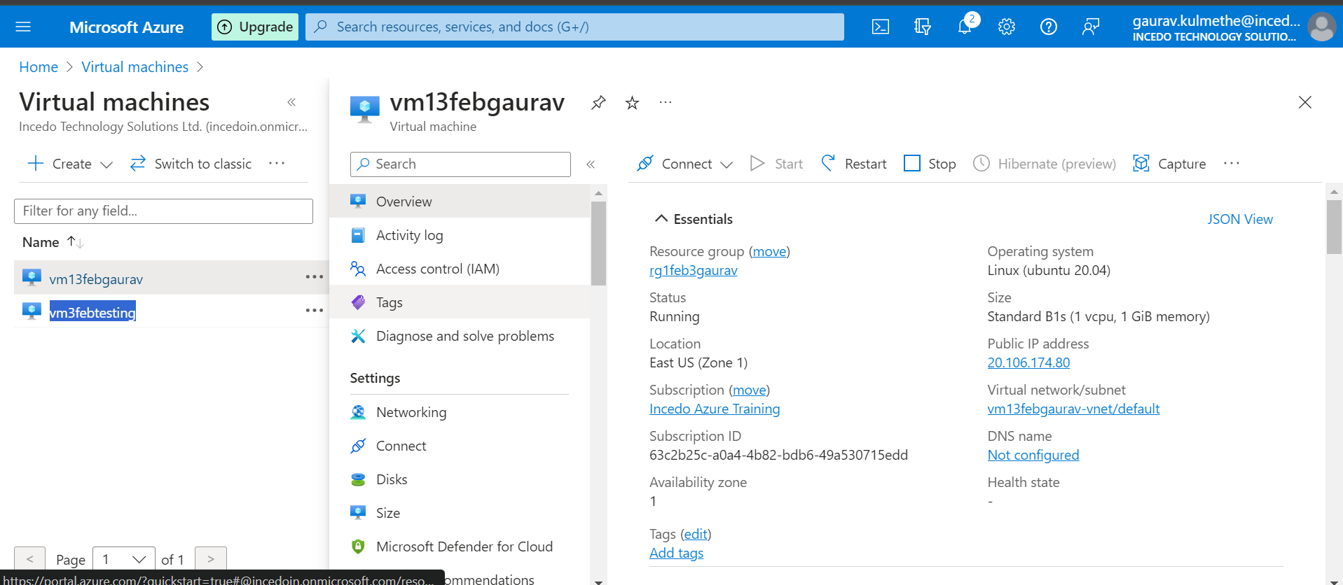

1. **2nd vm machine**

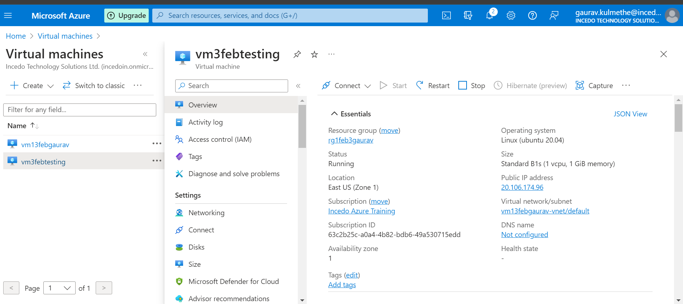

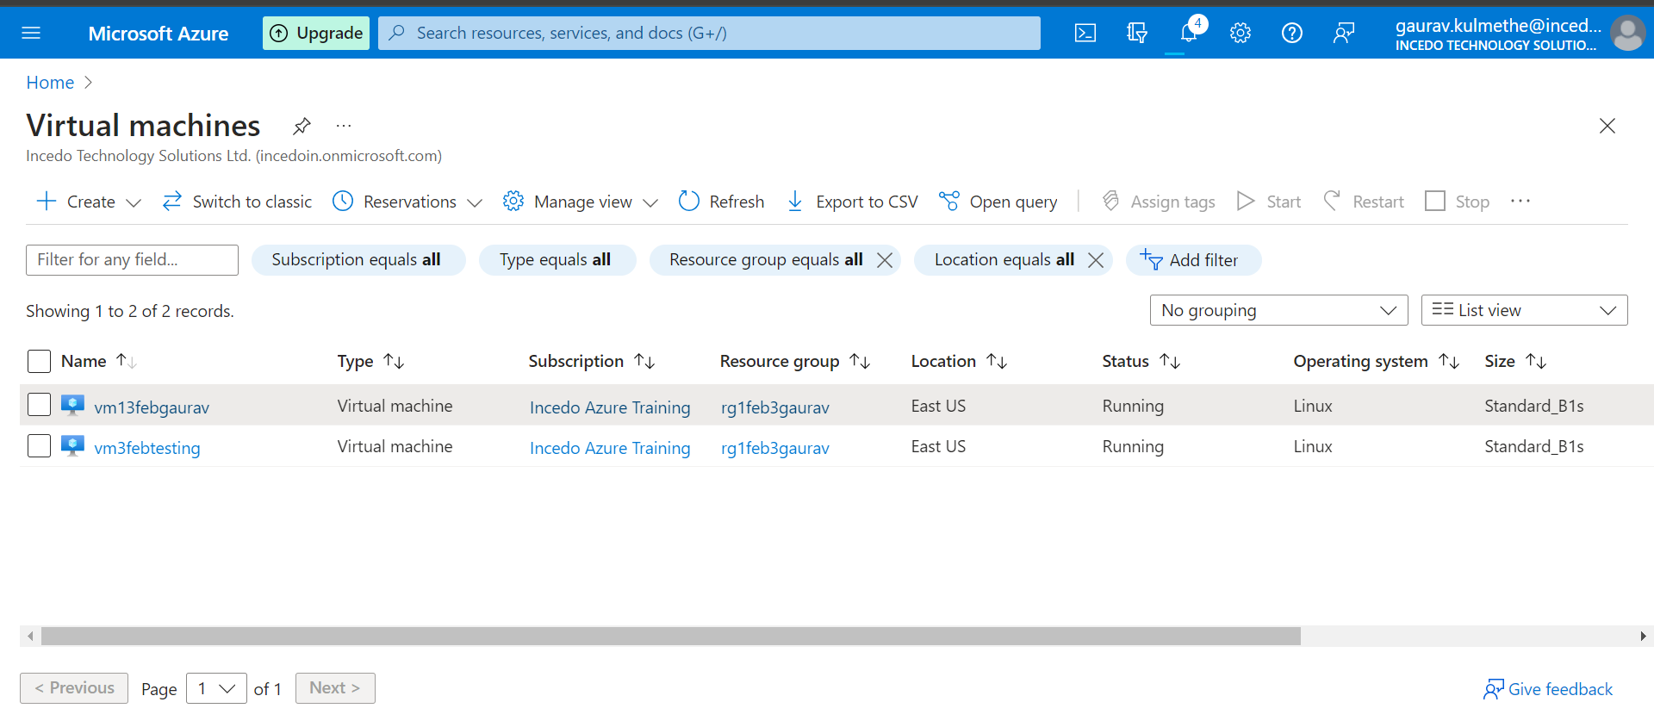

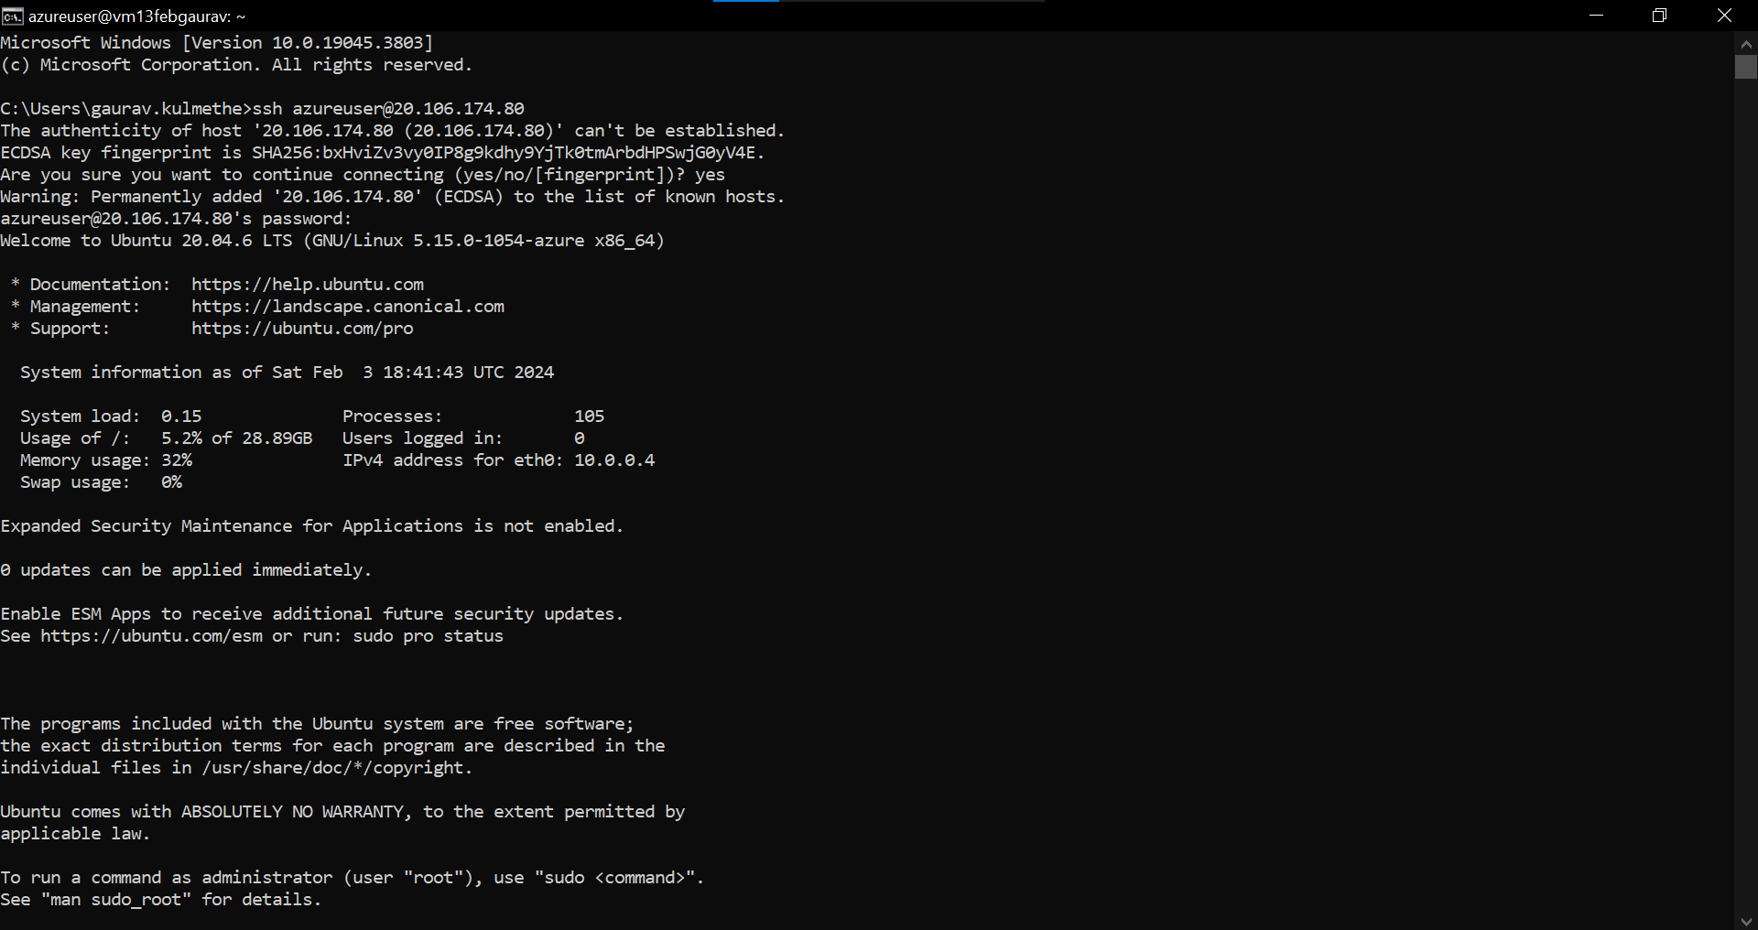

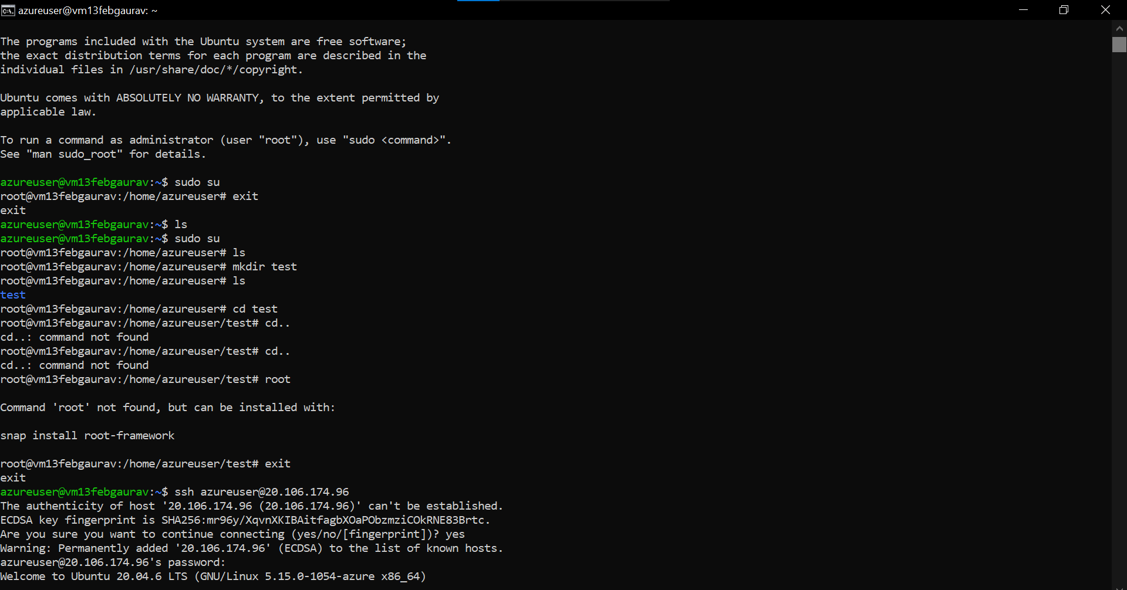

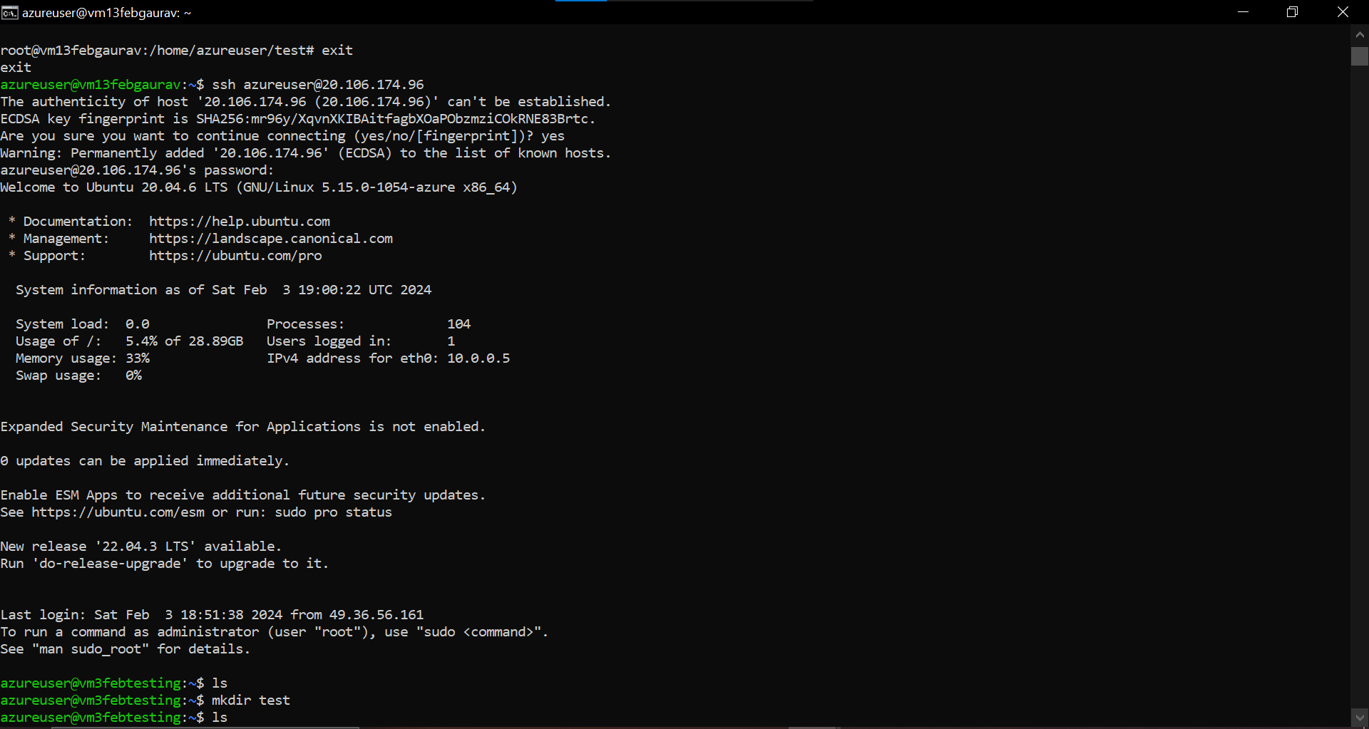

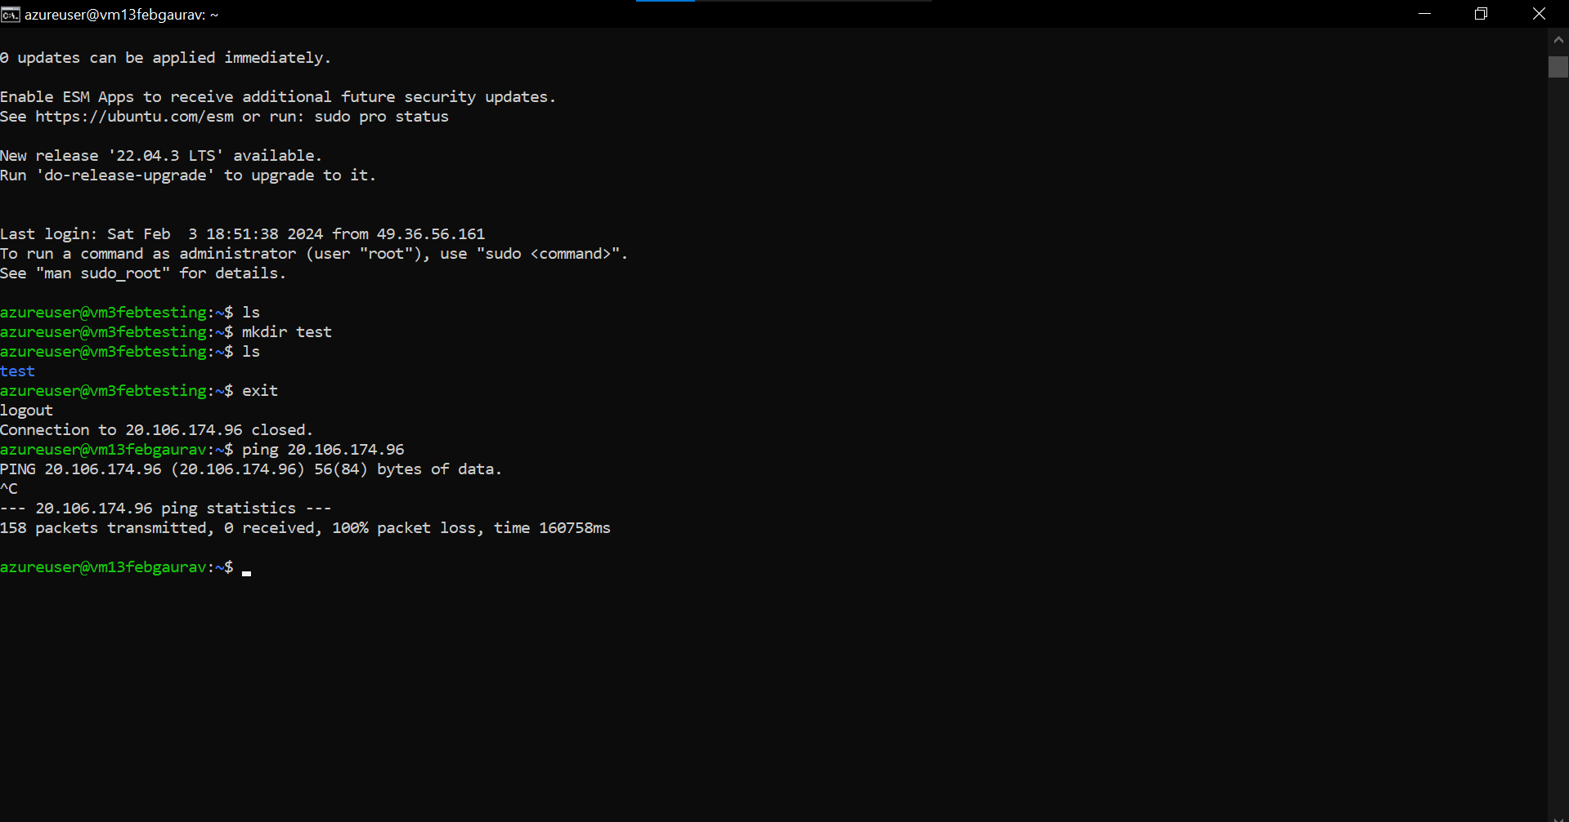

1. **2nd vm testing**

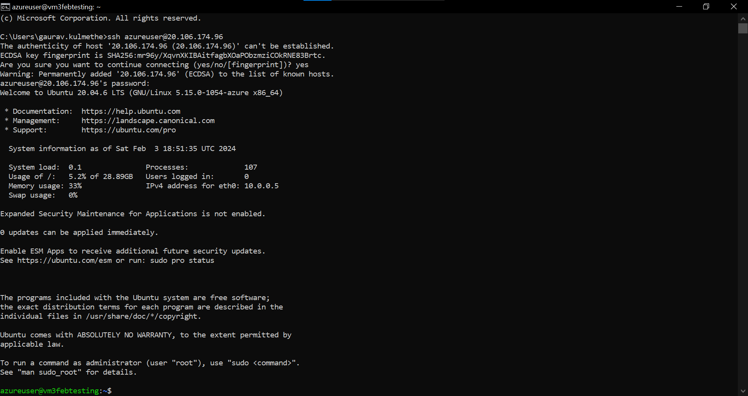

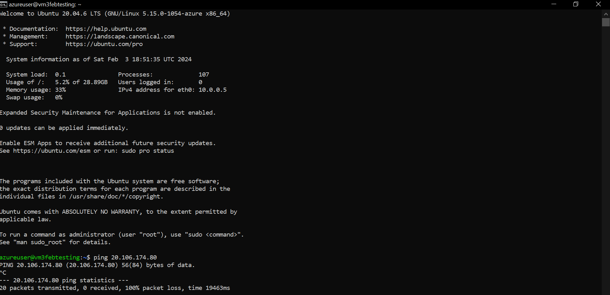

**Date 23-01-2024**

**Task – Create database and database server and connect with the dbeaver**

1. **Resource Group**

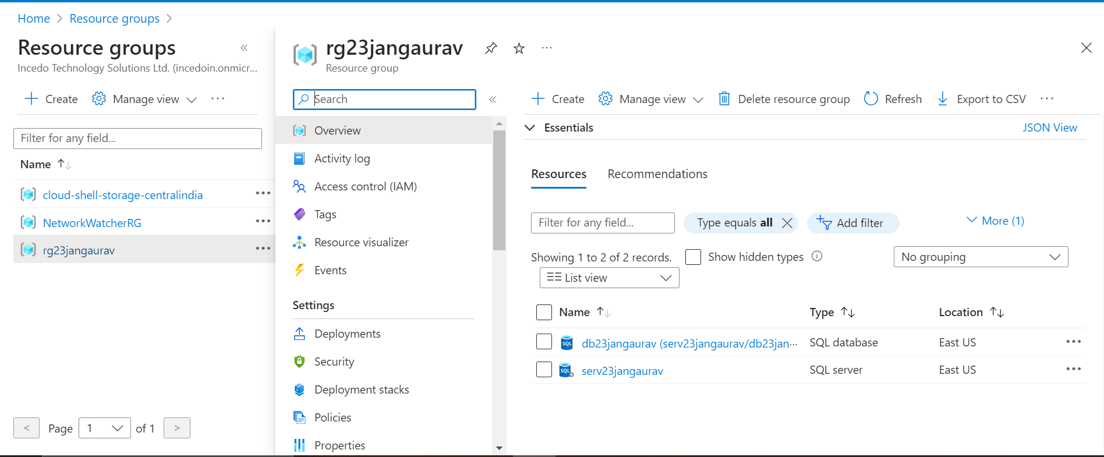

1. **SQL Database Server**

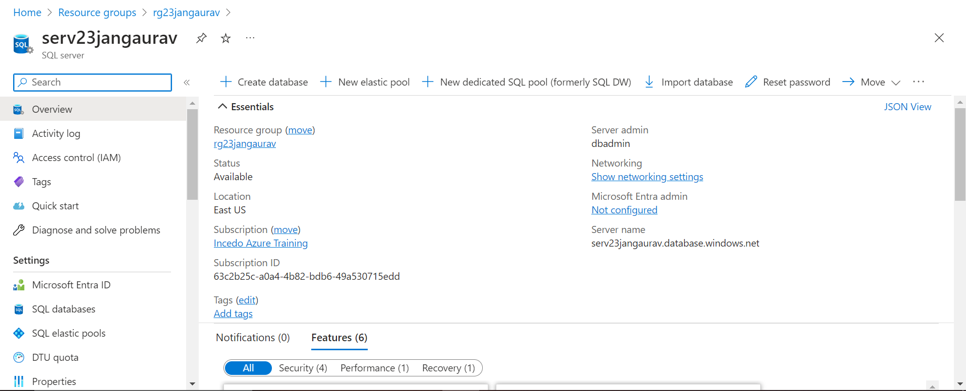

1. **SQL Database**

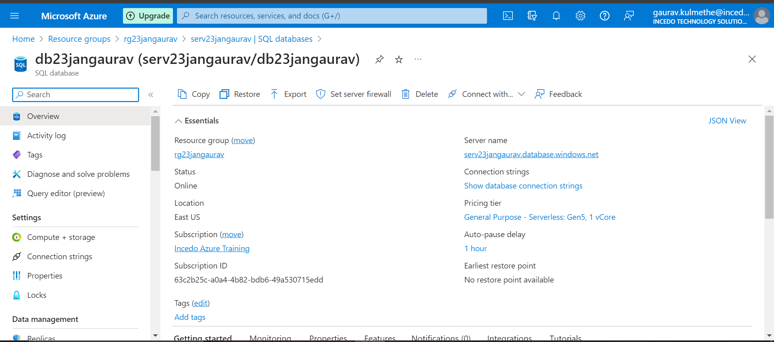

1. **Connecting to dbeaver**

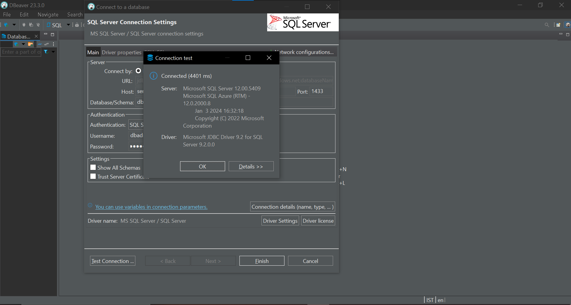

1. **Creating Table inside database**

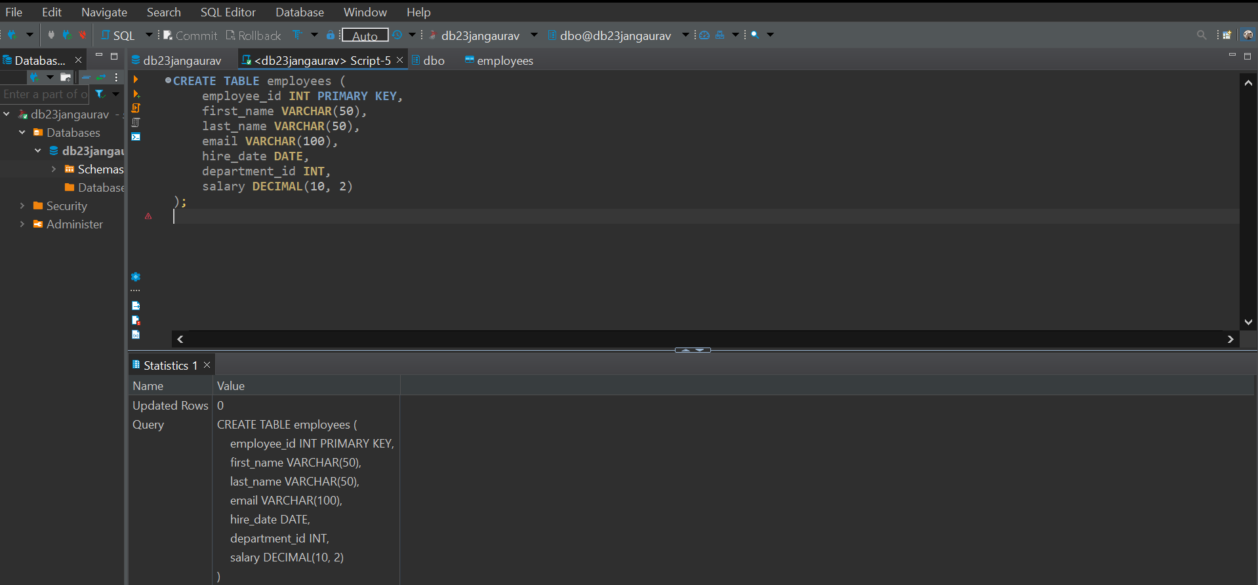

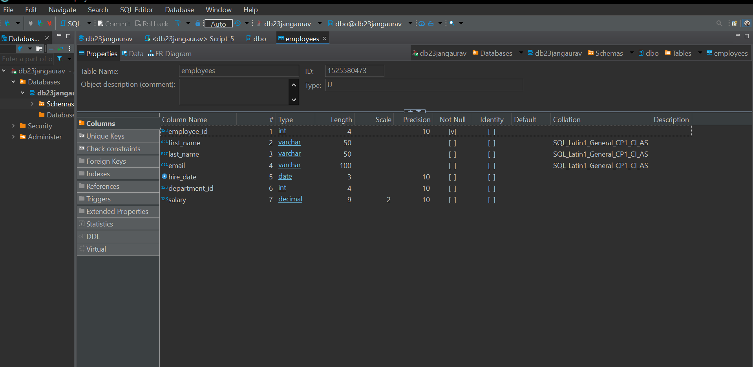

**Date 24-01-2024**  
  
**Task - Data containerization in cloud**  
  
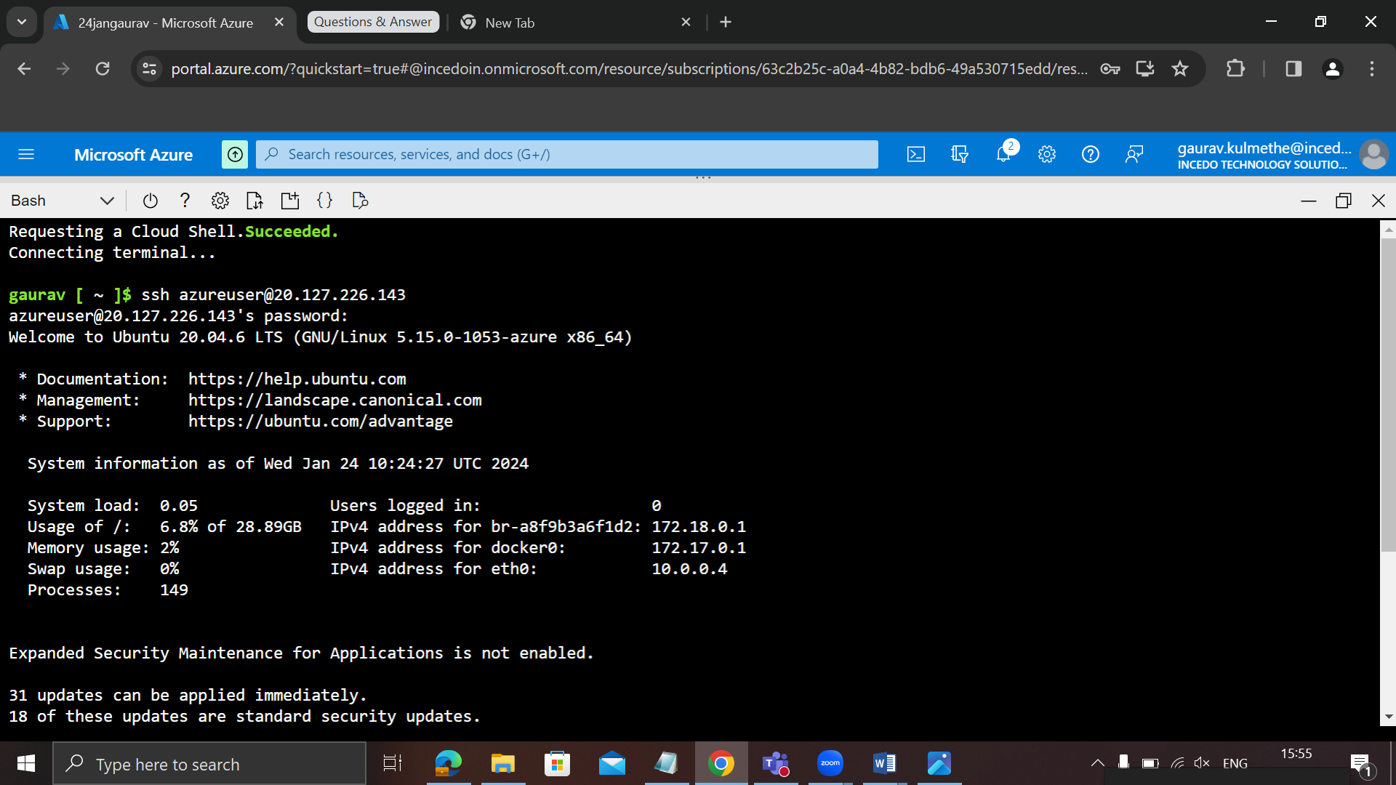

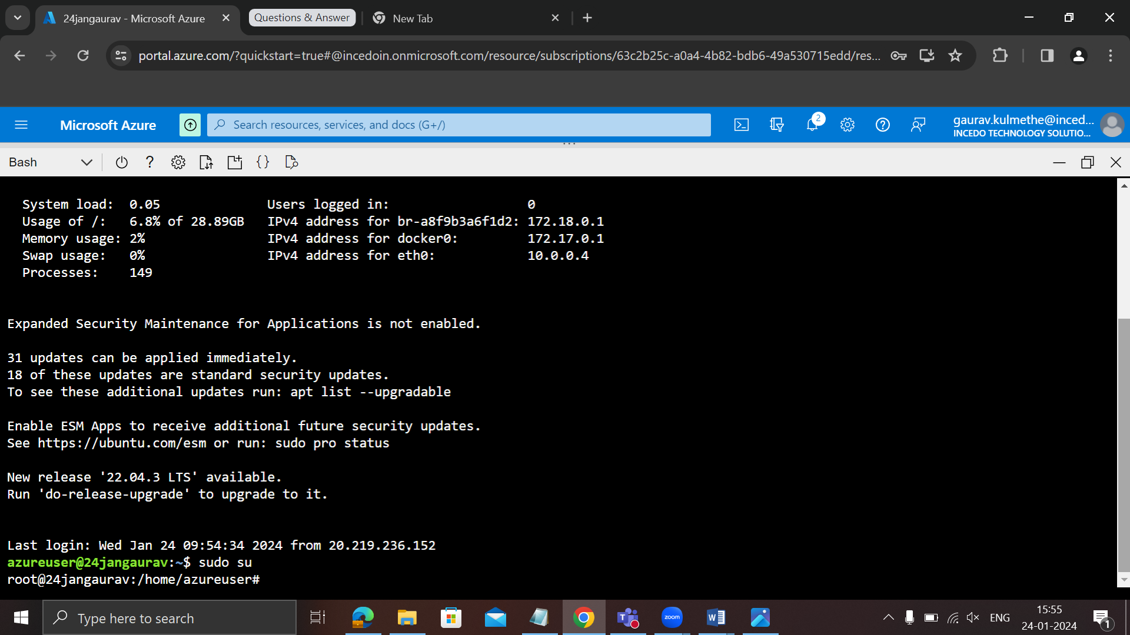

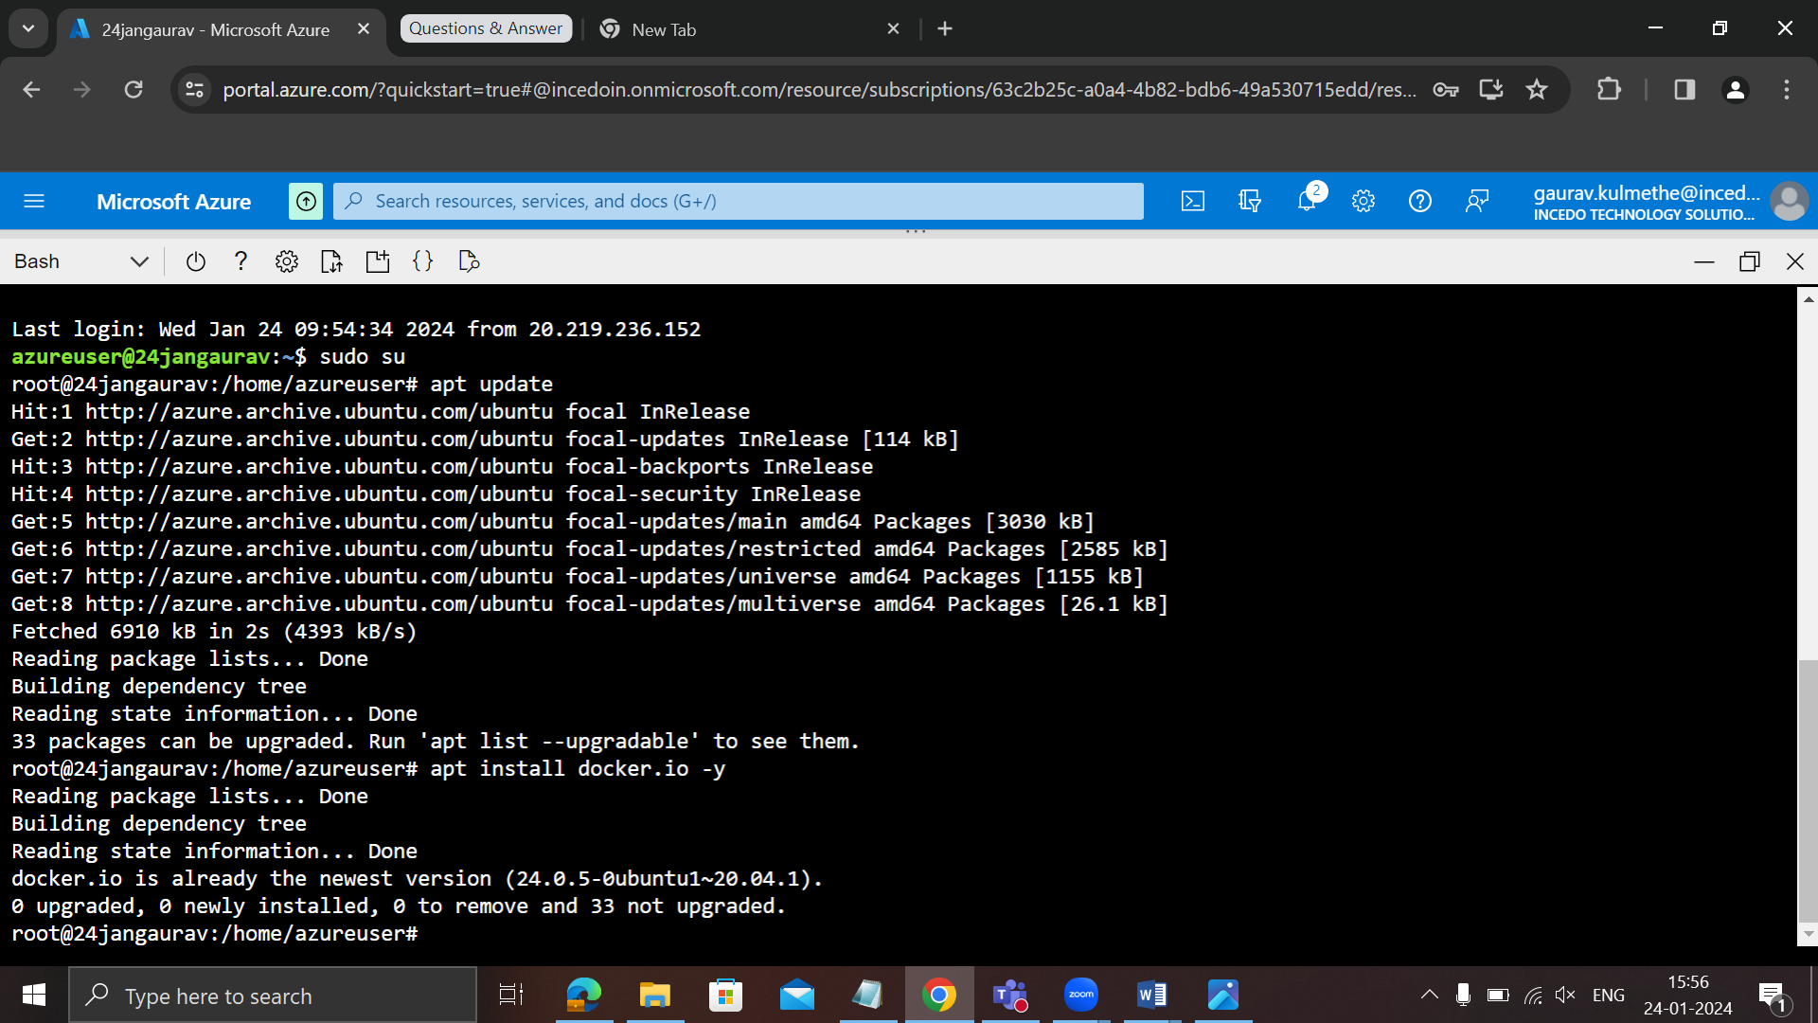

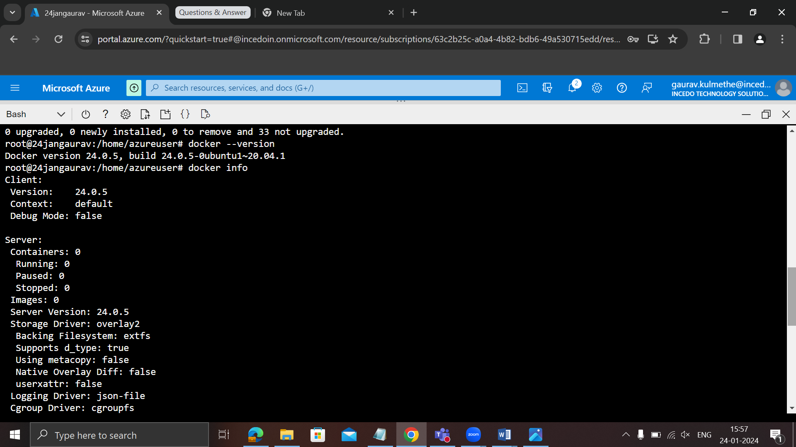

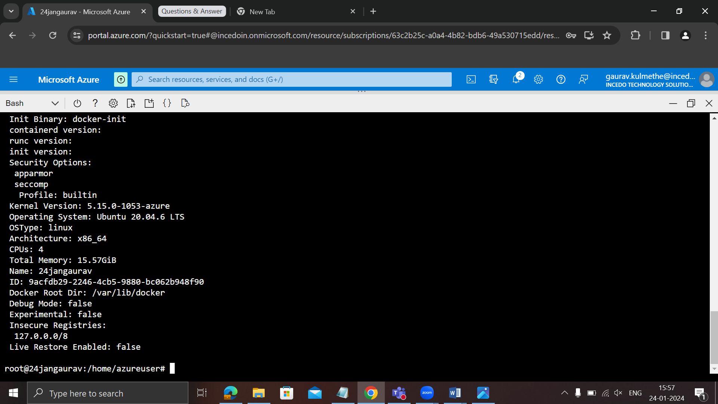

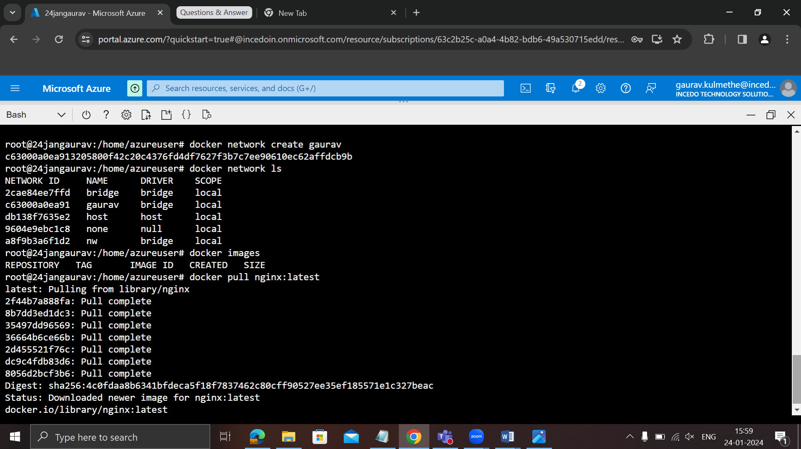

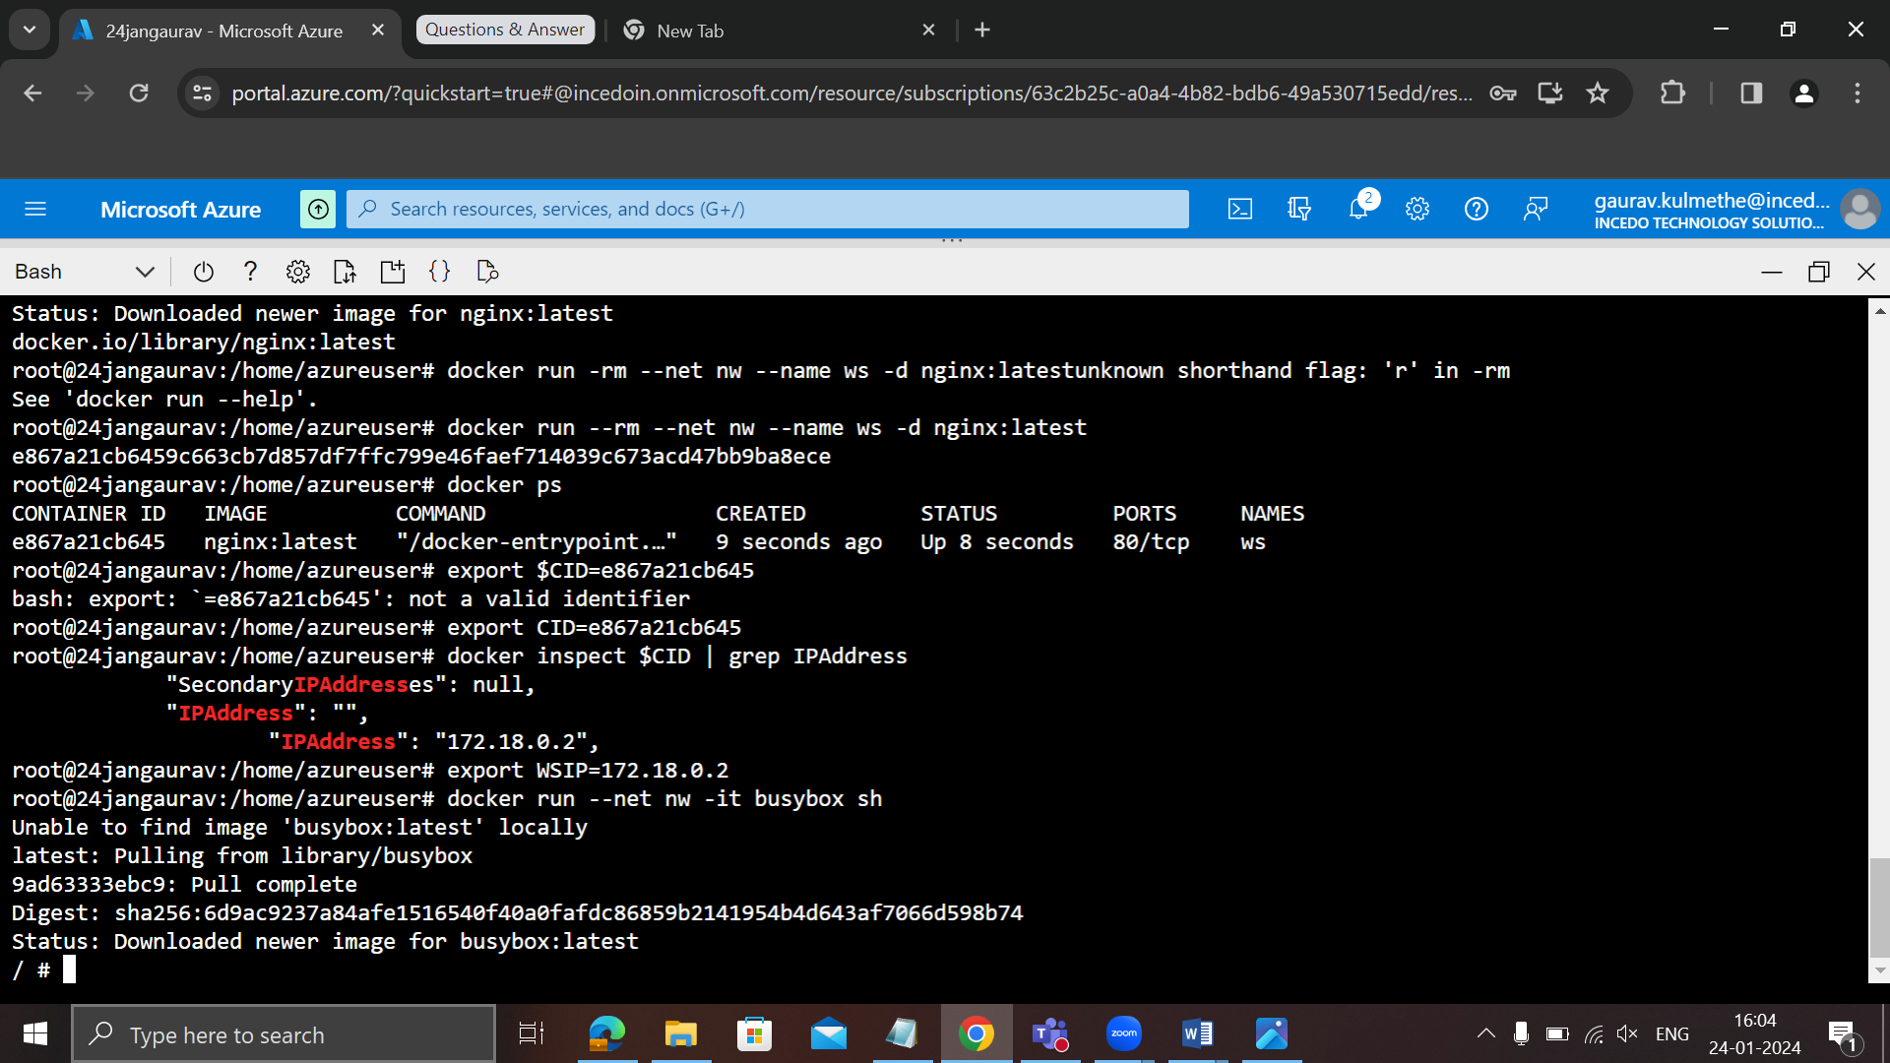

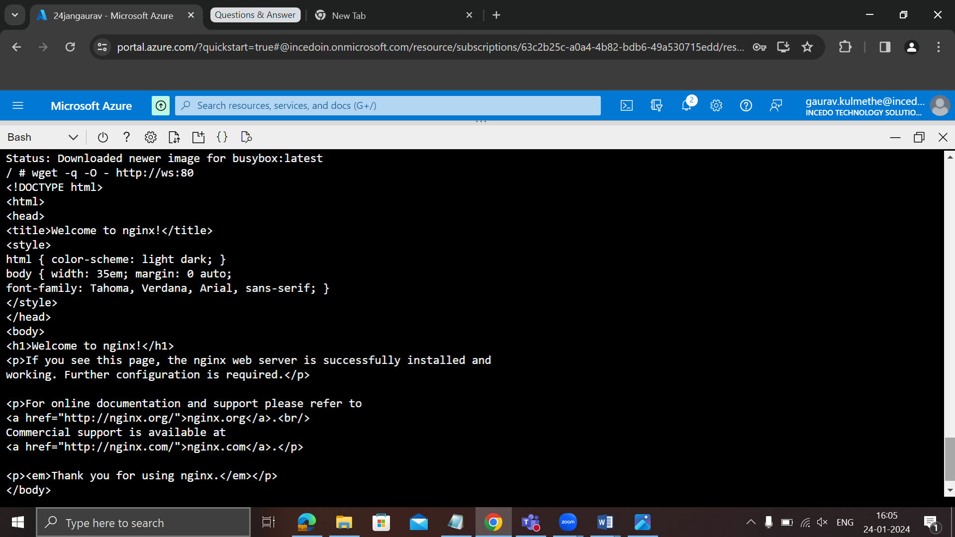

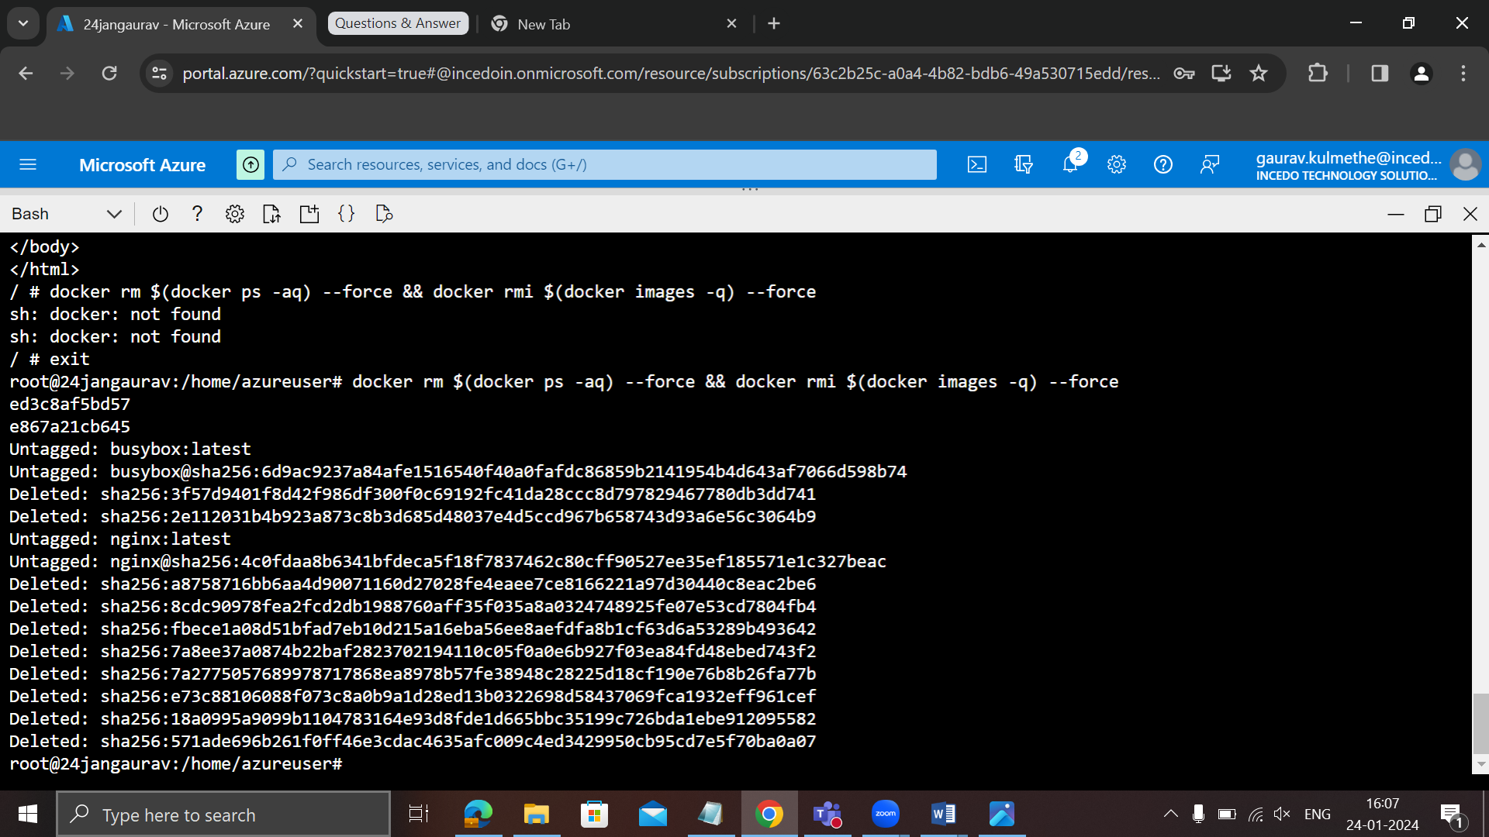

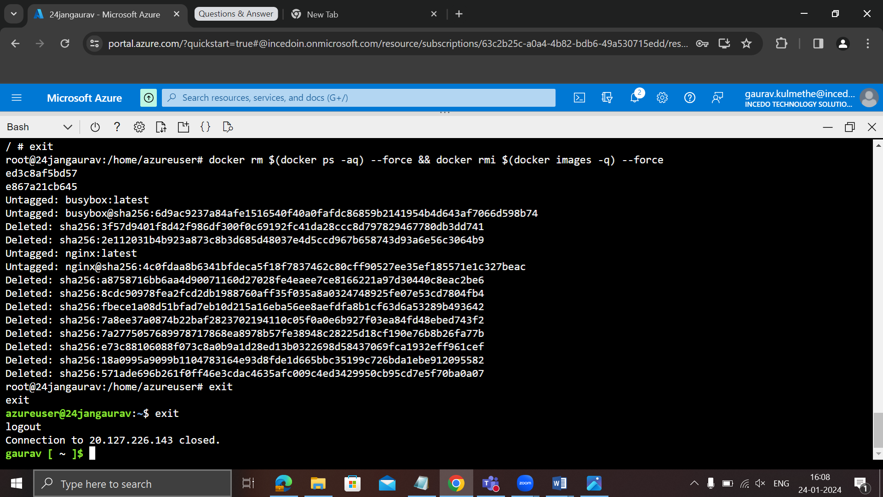

**Date 25-01-2024**

**Worked on Project of OTP Based authenticated app for learner and trainer**

**Azure load balancer dt. 29-01-2024**

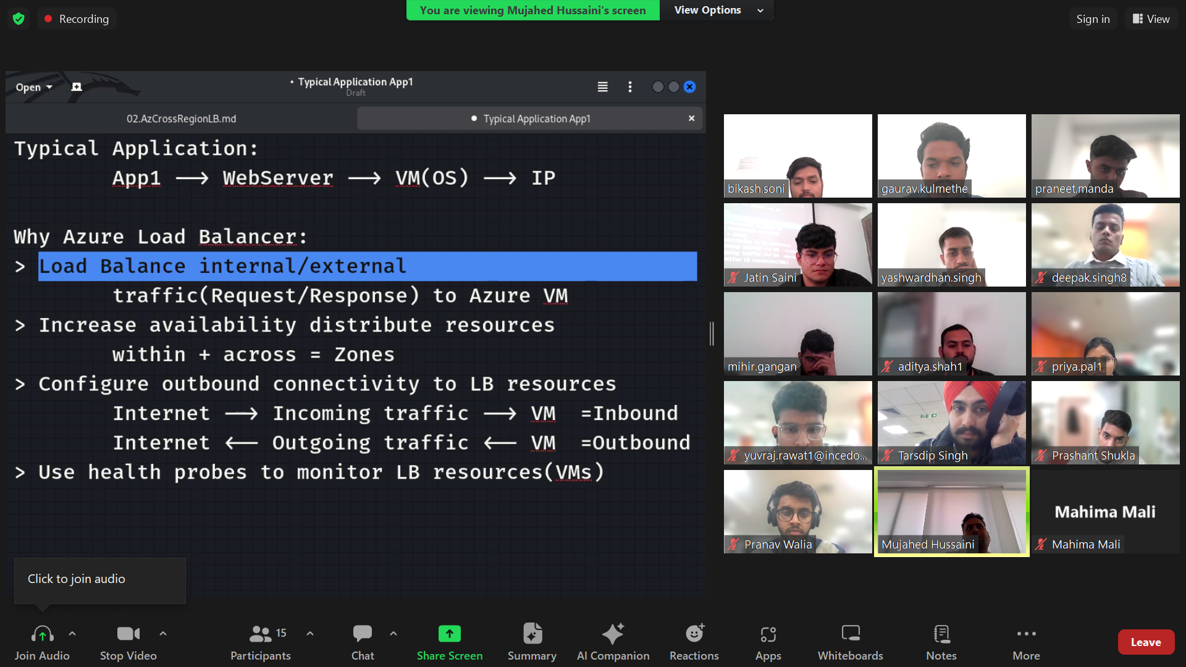

Inbound traffic –incoming traffic  
outbound traffic – outgoing traffic

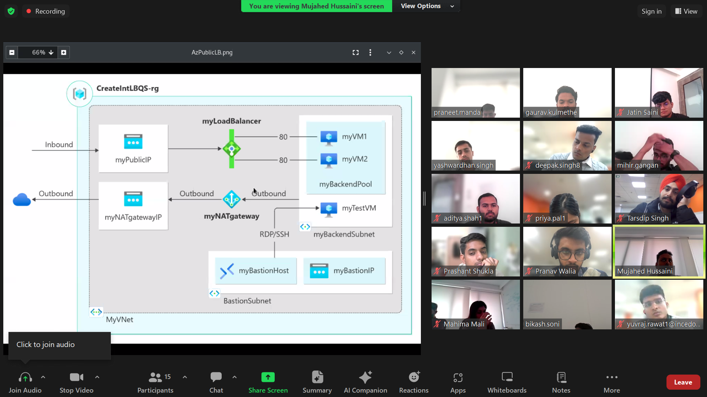

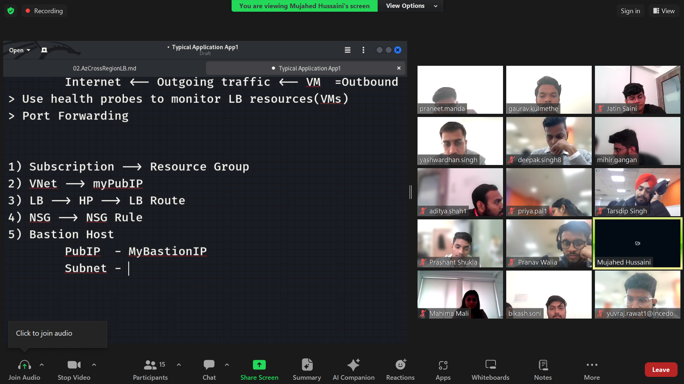

NAT – use for complete network

NIC – use for within the virtual machine

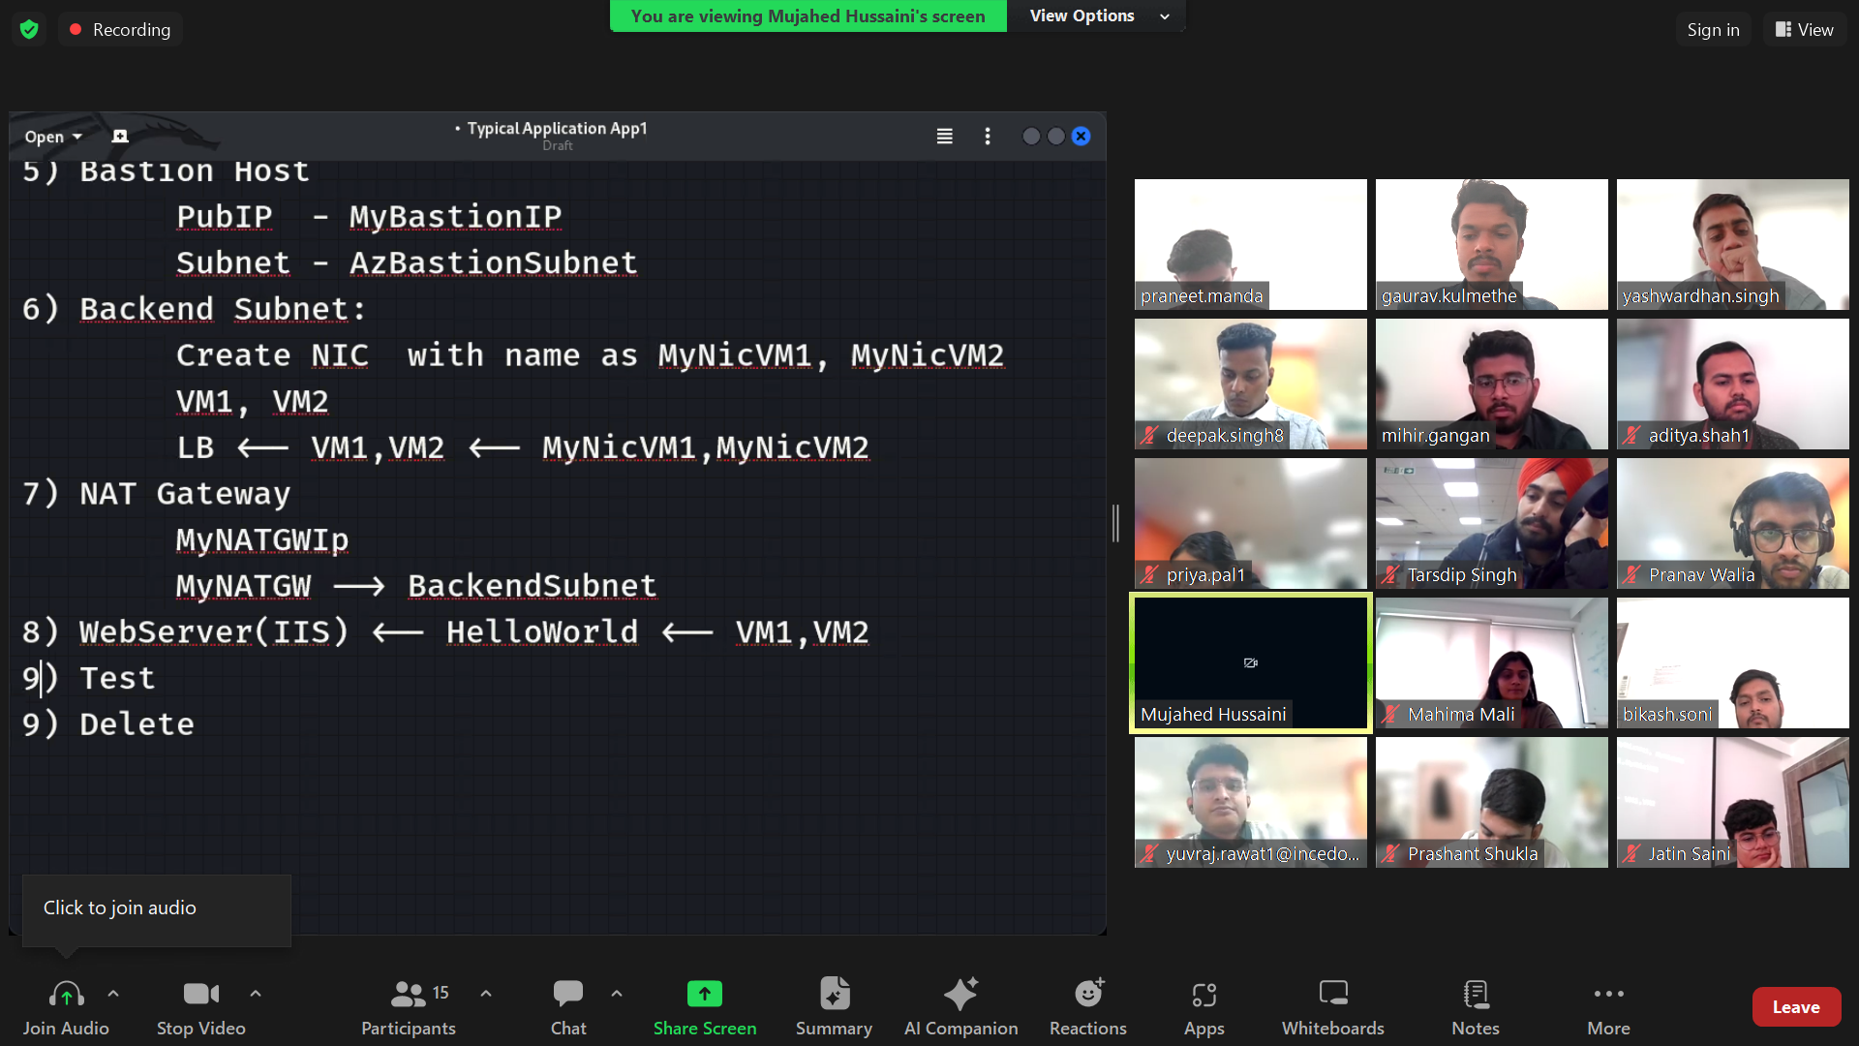

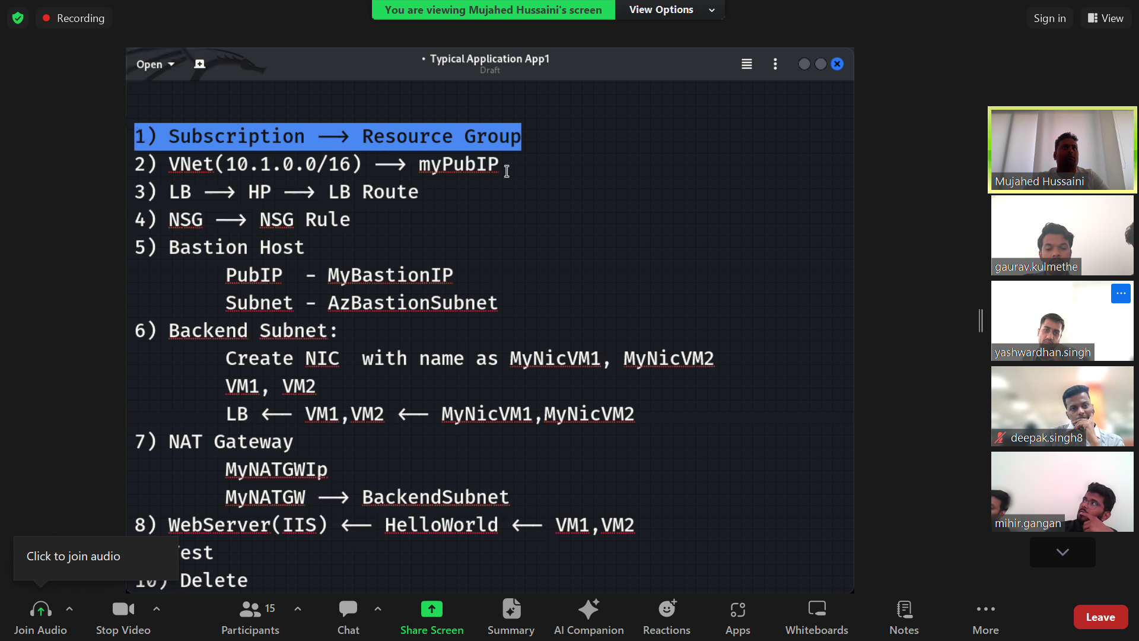

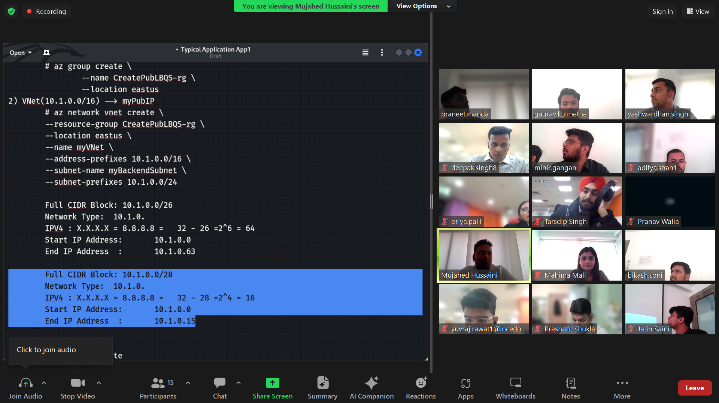

Health probe didn’t work on port number 443 https due to security concern

1. **Commands To Follow**

az network lb create \

--resource-group CreatePubLBQS-rg \

--name mylbgaurav \

--sku Standard \

--public-ip-address myPublicIP \

--frontend-ip-name myFrontEnd \

--backend-pool-name myBackEndPool

az network lb probe create \

--resource-group CreatePubLBQS-rg \

--lb-name mylbgaurav\

--name myHealthProbe \

--protocol tcp \

--port 80

az network lb rule create \

--resource-group CreatePubLBQS-rg \

--lb-name mylbgaurav \

--name myHTTPRule \

--protocol tcp --frontend-port 80 \

--backend-port 80 \

--frontend-ip-name myFrontEnd \

--backend-pool-name myBackEndPool \

--probe-name myHealthProbe \

--disable-outbound-snat true \

--idle-timeout 15 --enable-tcp-reset true

az network public-ip create --resource-group CreatePubLBQS-rg --name myBastionIP --sku Standard --zone 1 2 3

az network vnet subnet create \

--resource-group CreatePubLBQS-rg \

--name AzureBastionSubnet \

--vnet-name myVNet \

--address-prefixes 10.1.1.0/27

az network bastion create \

--resource-group CreatePubLBQS-rg \

--name myBastionHost \

--public-ip-address myBastionIP \

--vnet-name myVNet \

--location eastus

Admin password – Localhost@1234567

array=(myNicVM1 myNicVM2)

for vmnic in "${array[@]}"

do

az network nic create \

--resource-group CreatePubLBQS-rg \

--name $vmnic \

--vnet-name myVNet \

--subnet myBackEndSubnet \

--network-security-group myNSG

done

az vm create \

--resource-group CreatePubLBQS-rg \

--name myVM1 \

--nics myNicVM1 \

--image win2019datacenter \

--admin-username azureuser \

--zone 1 --no-wait  
  
  
az vm create \

--resource-group CreatePubLBQS-rg \

--name myVM2 \

--nics myNicVM2 \

--image win2019datacenter \

--admin-username azureuser \

--zone 2 --no-wait

array=(myNicVM1 myNicVM2)

for vmnic in "${array[@]}"

do

az network nic ip-config address-pool add \

--address-pool myBackendPool \

--ip-config-name ipconfig1 \

--nic-name $vmnic \

--resource-group CreatePubLBQS-rg \

--lb-name myLBMujahed

done

az network public-ip create \

--resource-group CreatePubLBQS-rg \

--name myNATgatewayIP \

--sku Standard \

--zone 1 2 3  
  
az network nat gateway create \  
    --resource-group CreatePubLBQS-rg \  
    --name myNATgateway \  
    --public-ip-addresses myNATgatewayIP \  
    --idle-timeout 10

az network vnet subnet update \  
        --resource-group CreatePubLBQS-rg \  
        --vnet-name myVNet \  
        --name myBackendSubnet \  
        --nat-gateway myNATgateway

array=(myVM1 myVM2)  
    for vm in "${array[@]}"  
    do  
        az vm extension set \  
            --publisher Microsoft.Compute \  
            --version 1.8 --name CustomScriptExtension \  
            --vm-name $vm --resource-group CreatePubLBQS-rg \  
            --settings '{"commandToExecute":"powershell Add-WindowsFeature Web-Server; powershell Add-Content -Path \"C:\\inetpub\\wwwroot\\Default.htm\" -Value $($env:computername)"}'  
    done  
  
change name of default to your name eg Gaurav  
  
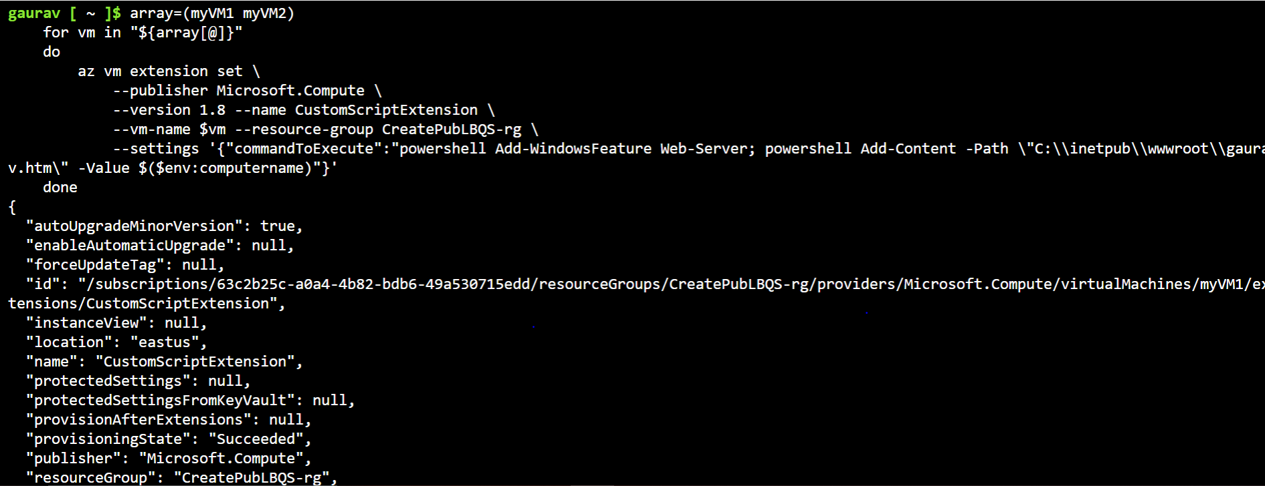  
  




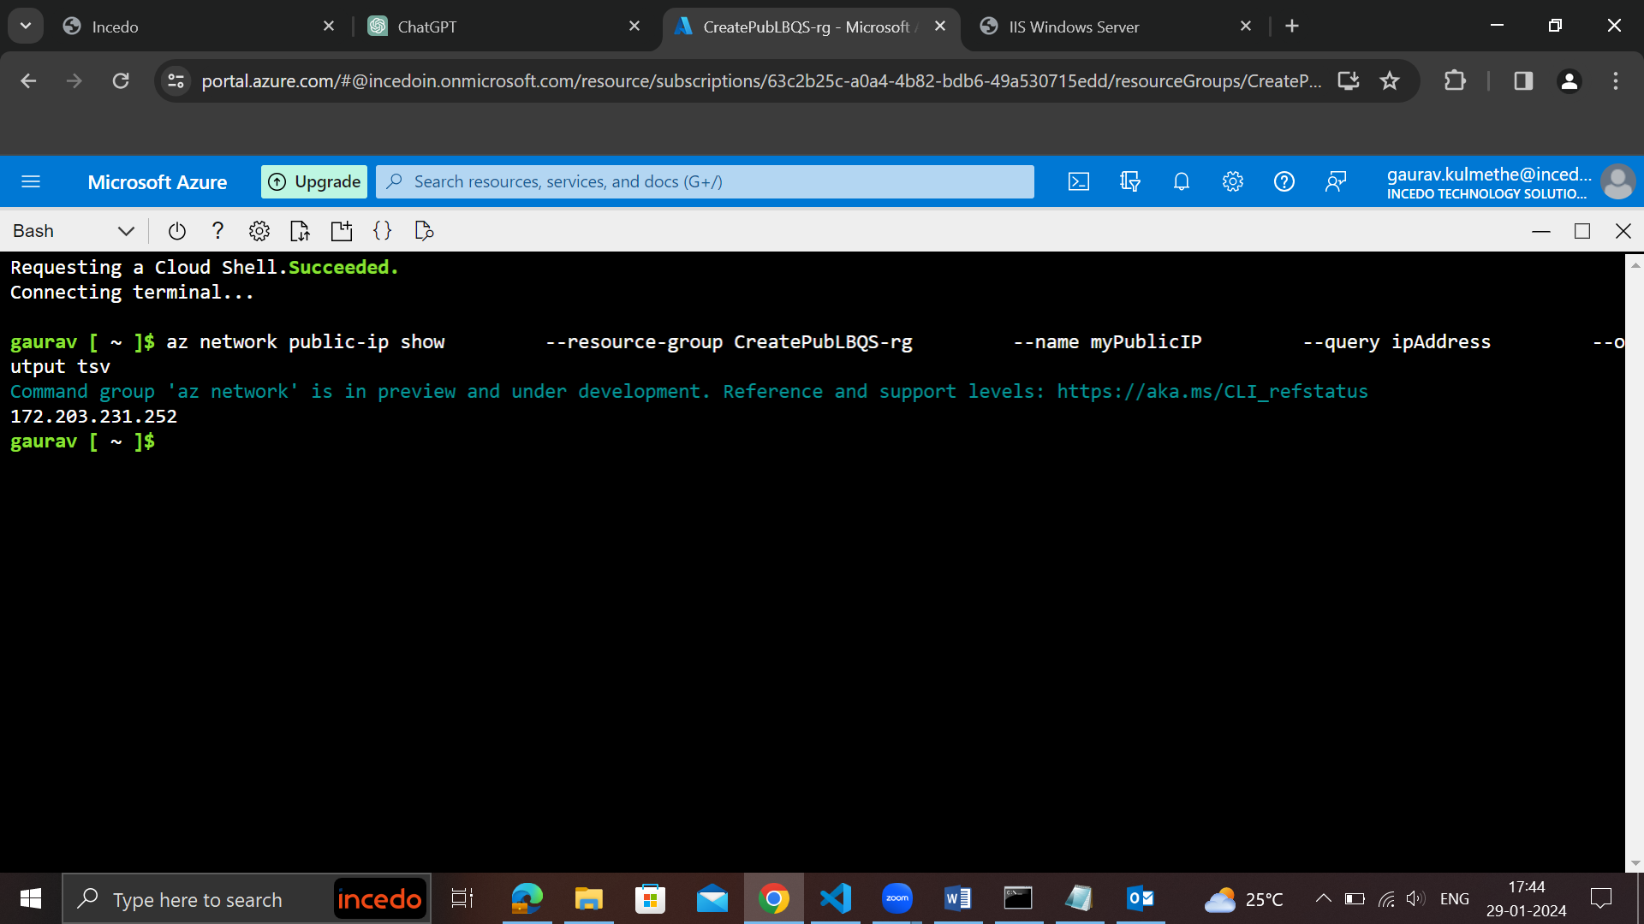

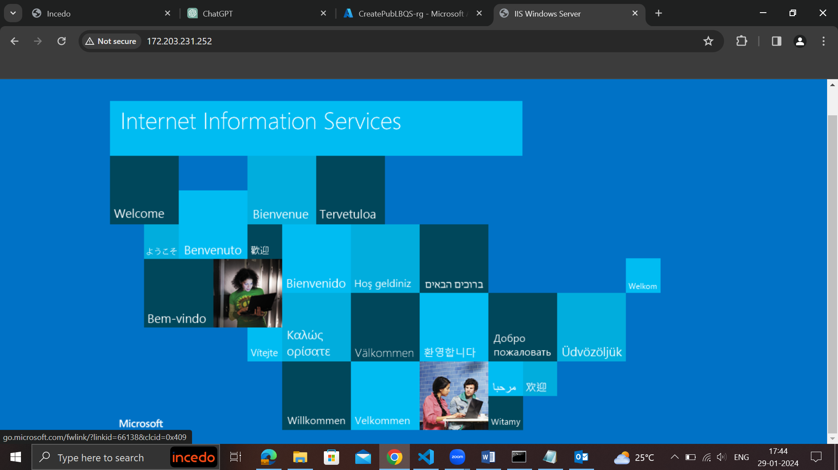

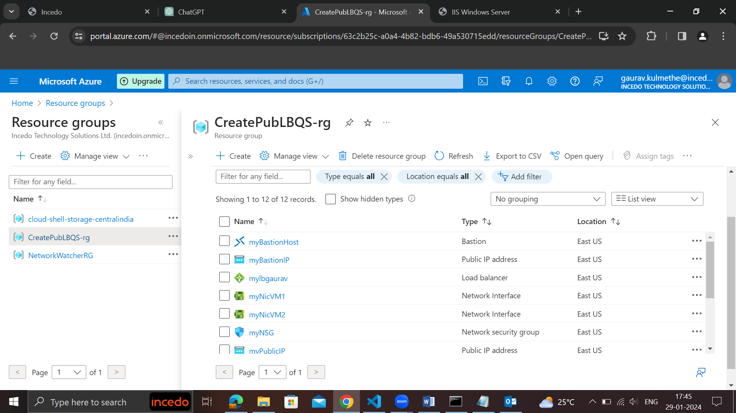

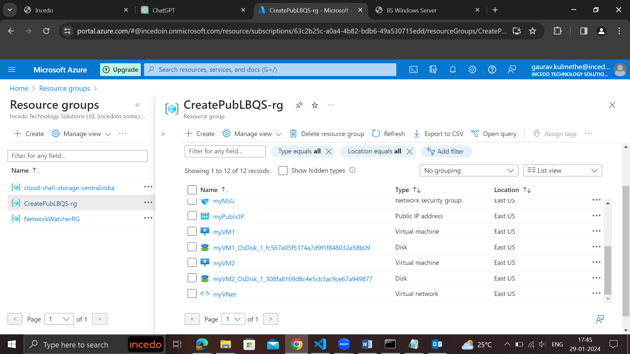

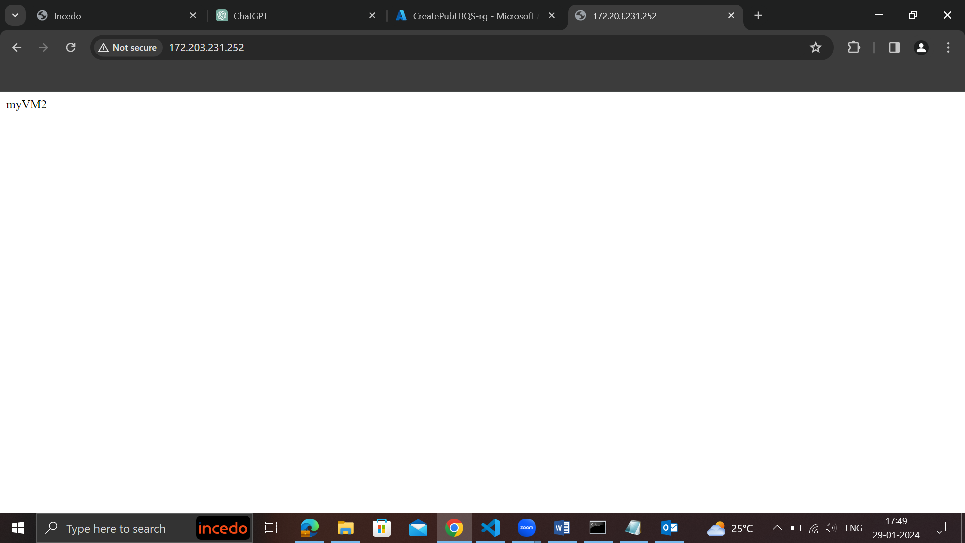

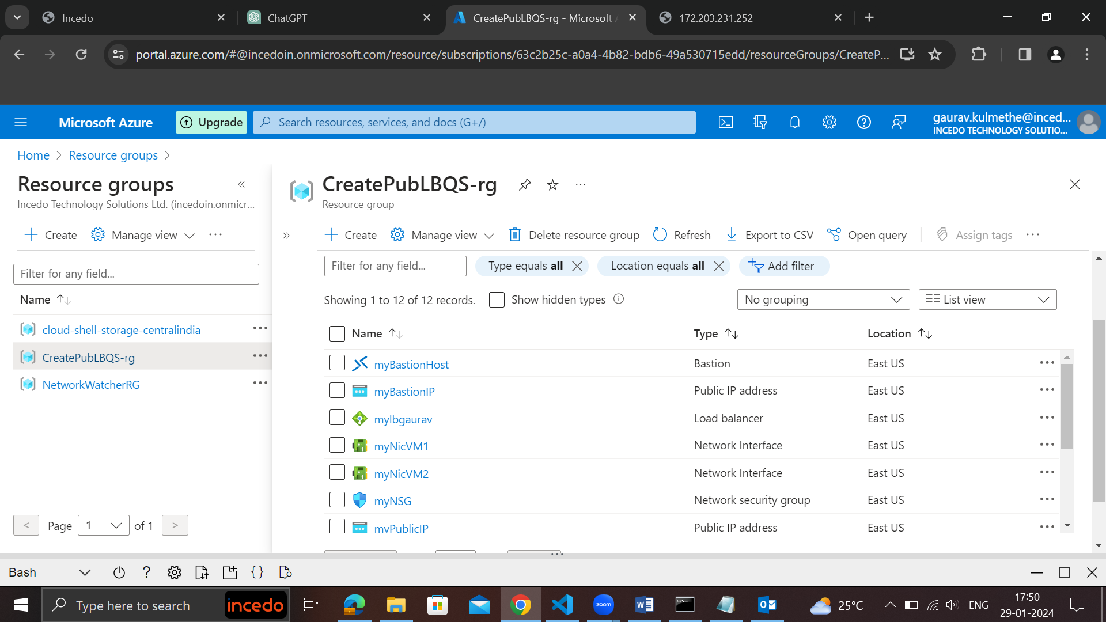

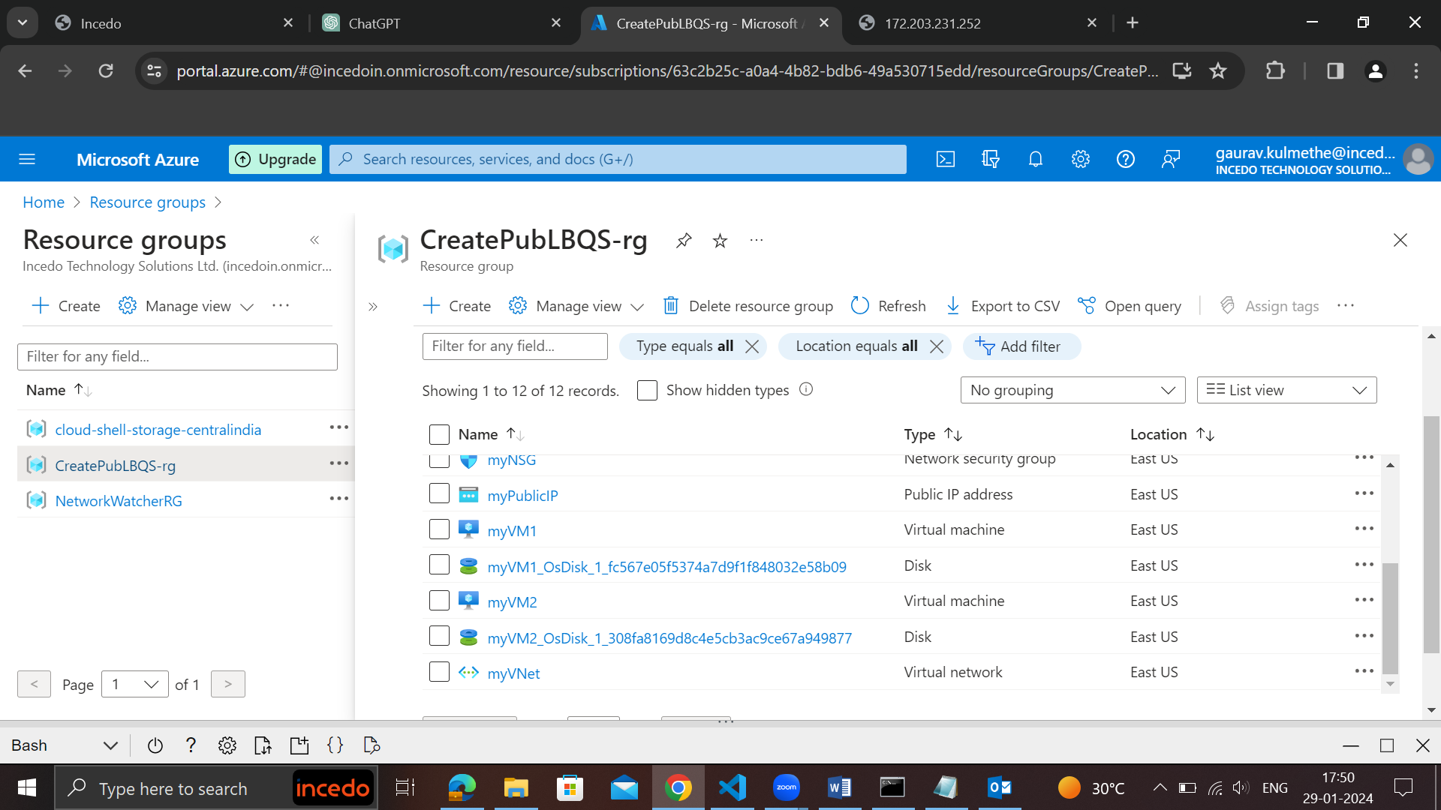

After stopping vm1

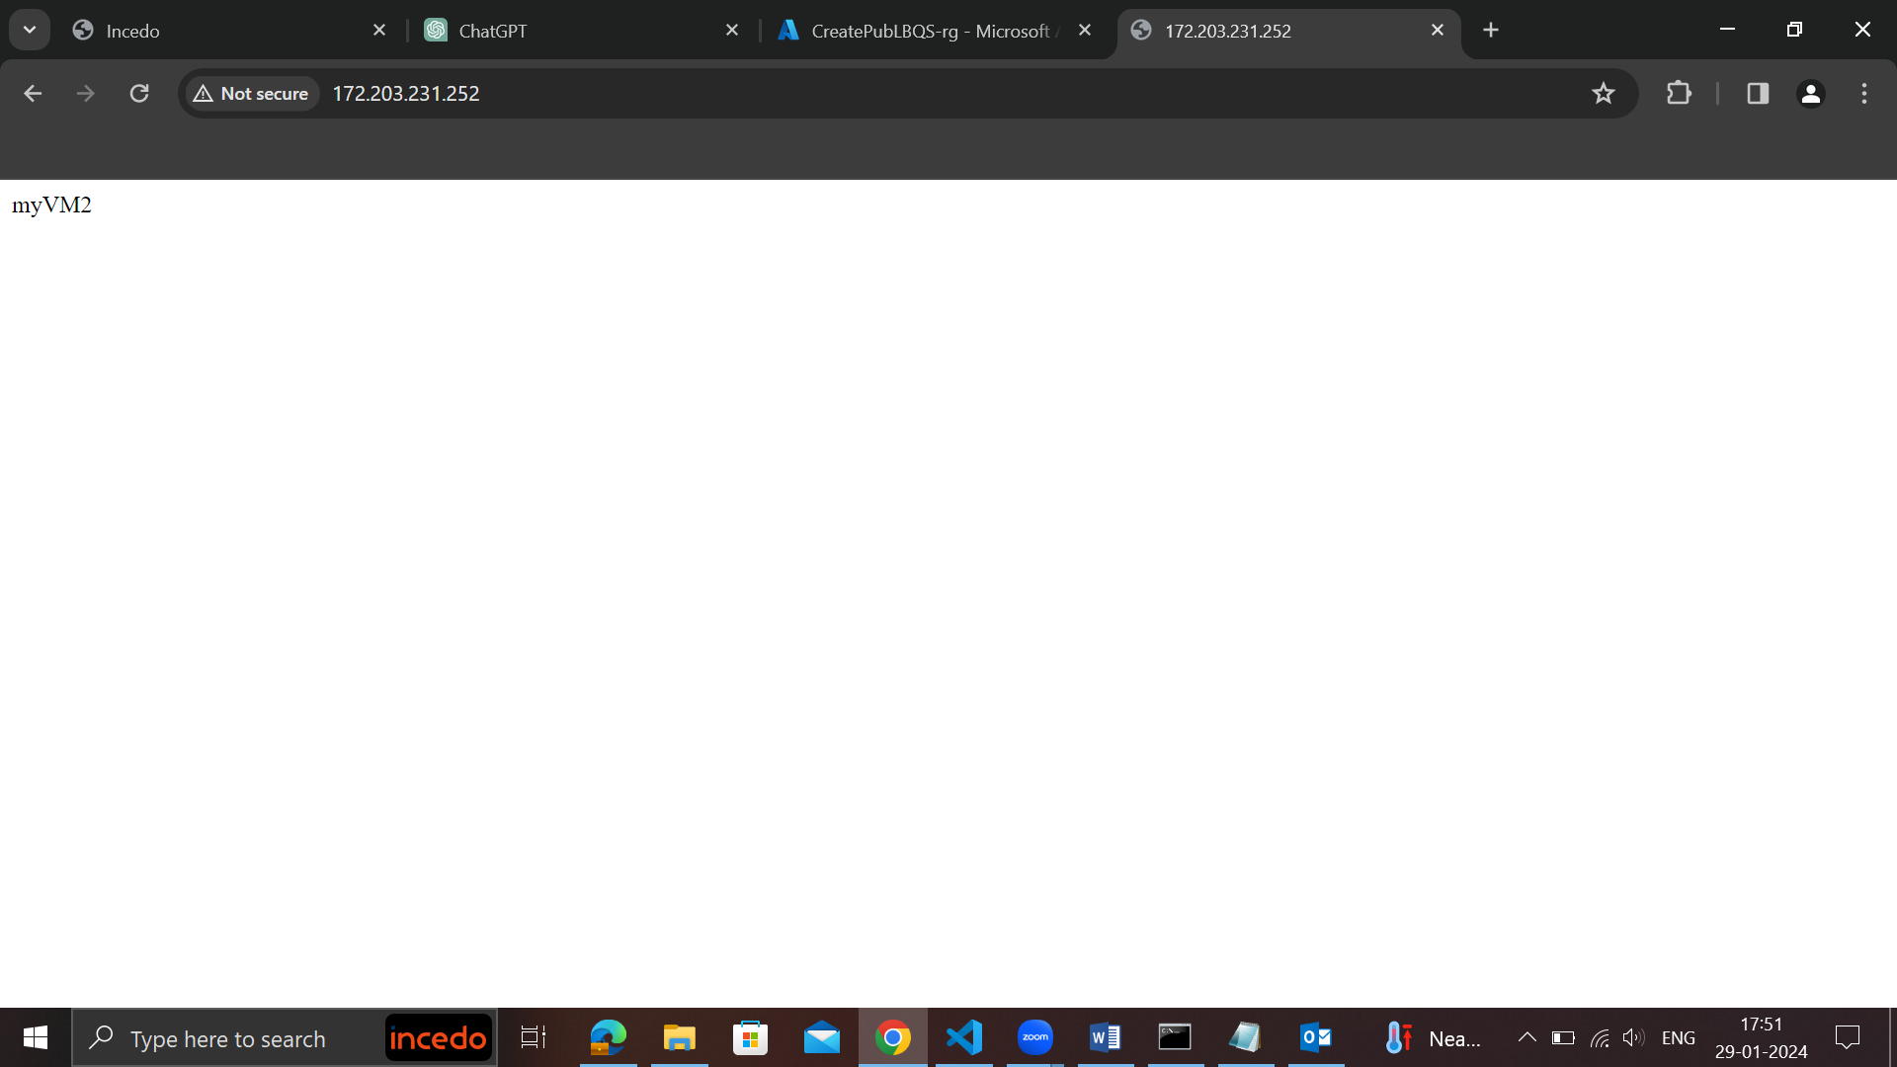

After stopping vm2

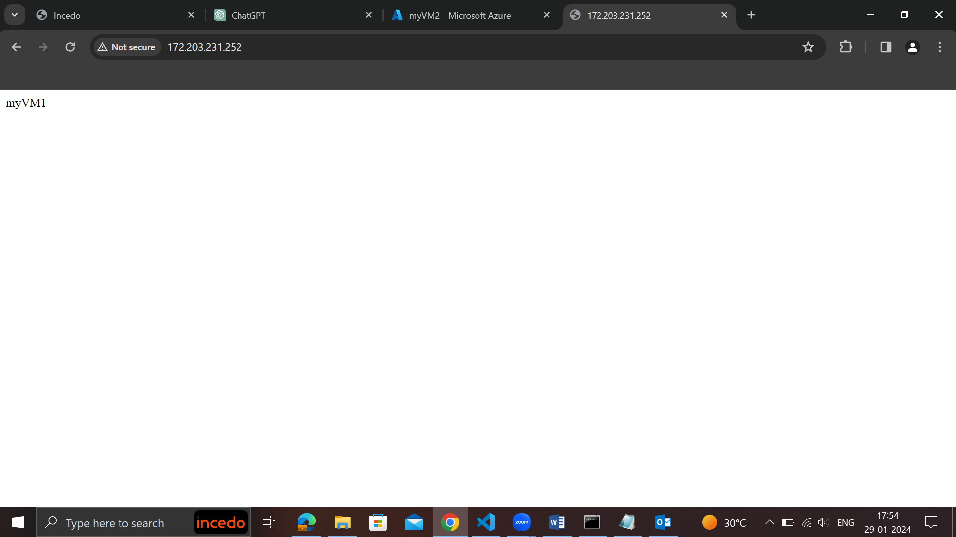

<https://github.com/NubeEra-Samples/AzureServices>

**dated 30-01-2023**

1. **Project Work continued and learnt about agile methodologies and tool used industry.**

SAST  
for agile paid tool jira  
before jira, trello, integrate with version control system  
how to work with the treelo ,jira ticketing categoroy tools

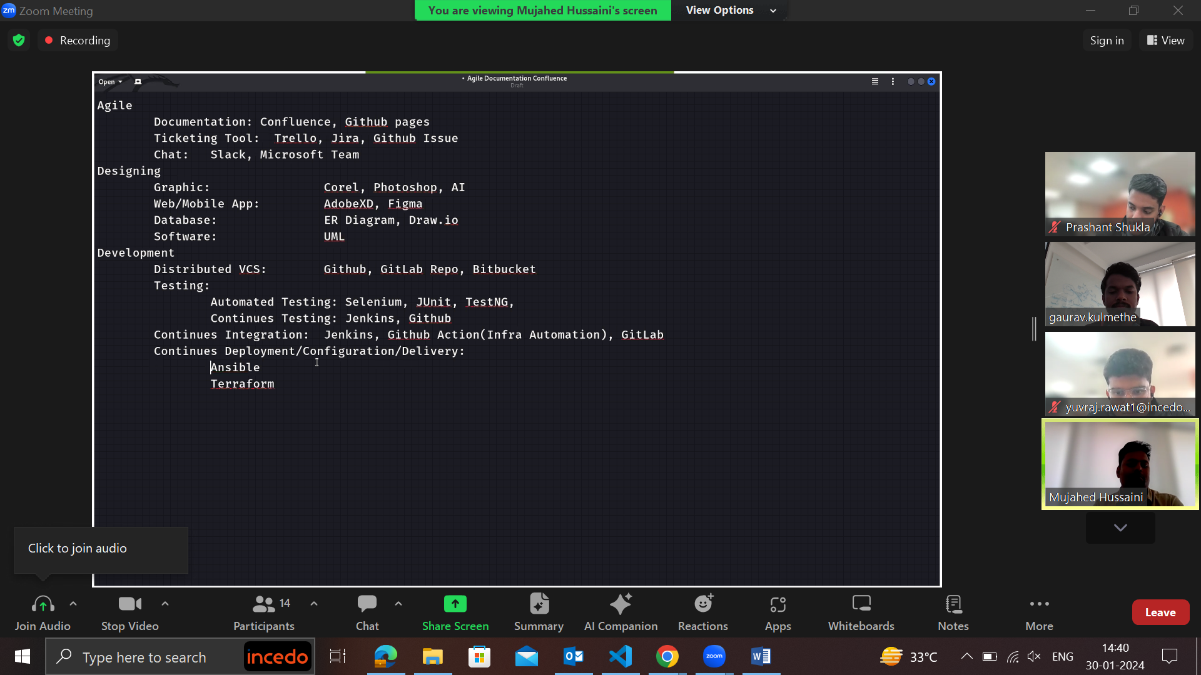

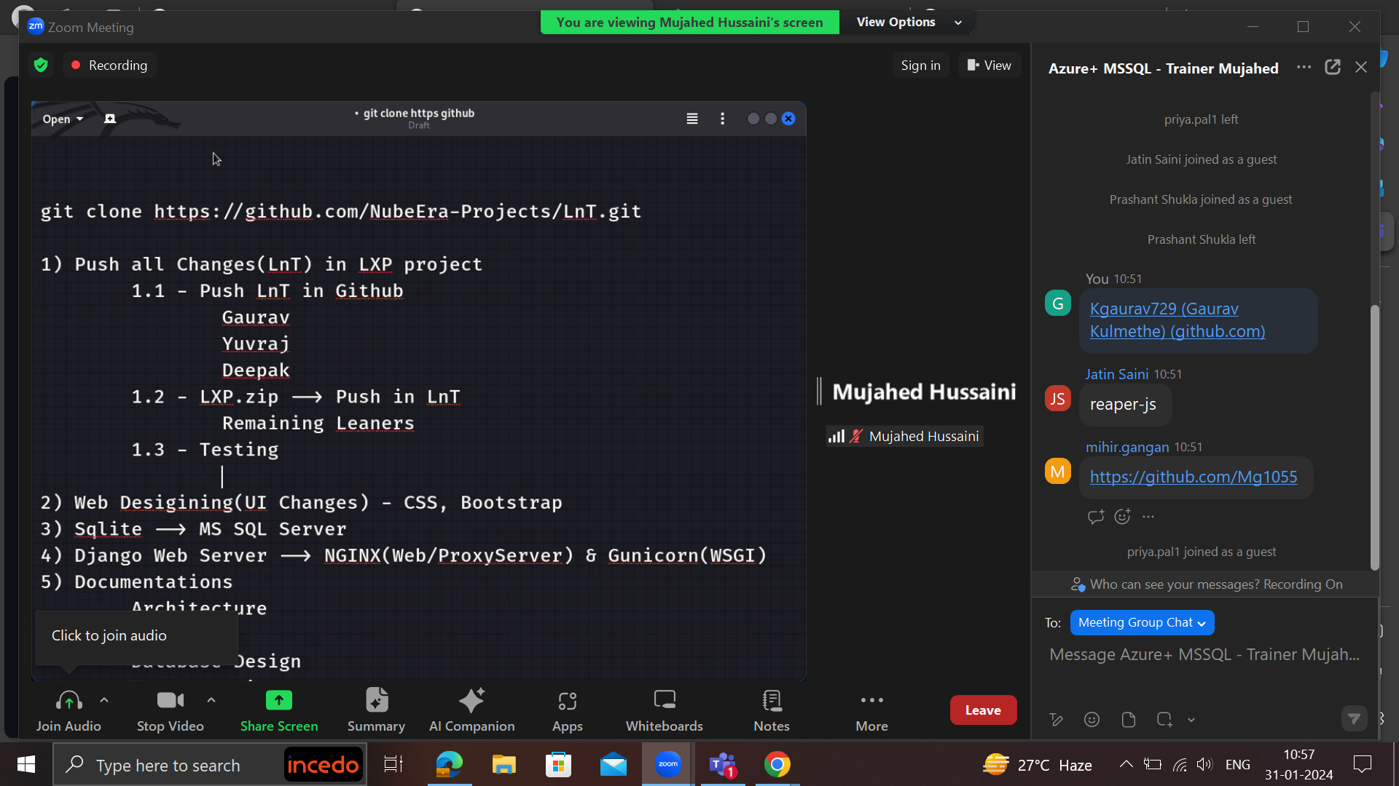

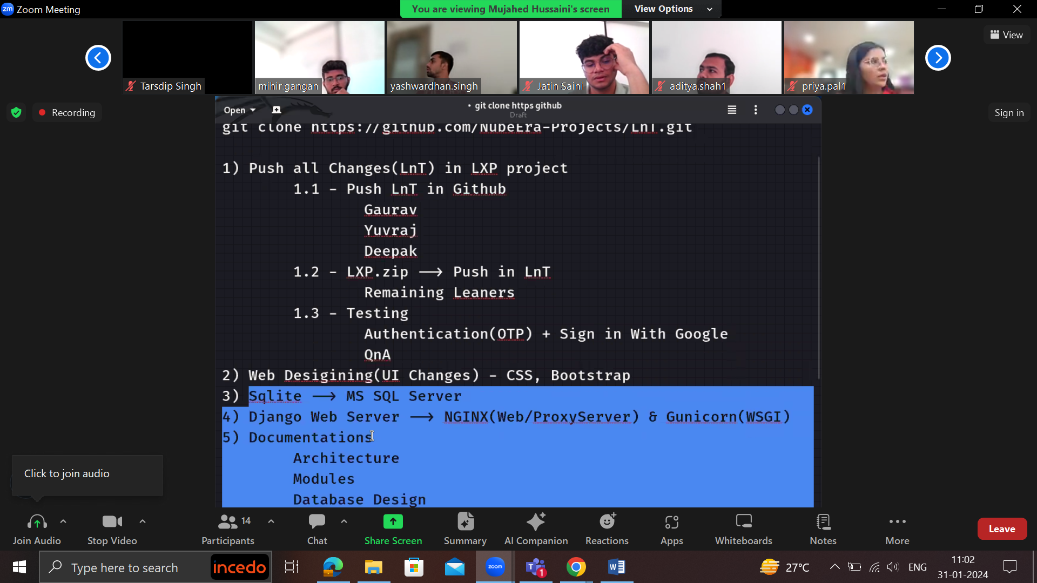

**31St Jan 2024**

1. **Completed version 1 and explored version 2 of the project**

**ETL – Extract Transform Load 2feb 2024**

1. **Creating resource grp**

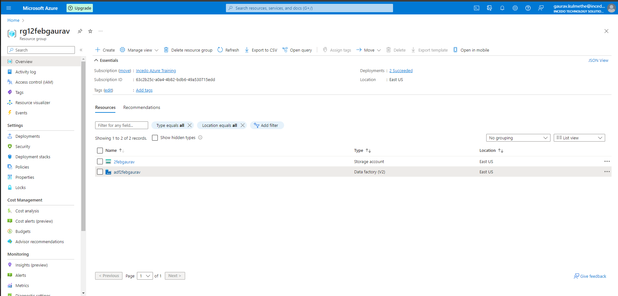

1. **Creating storage accounts**

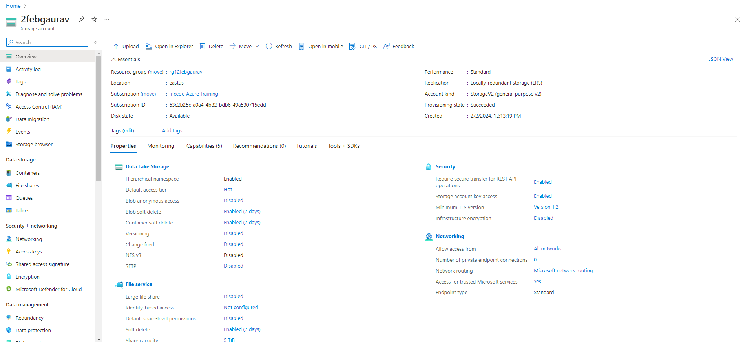

1. **Creating containers**

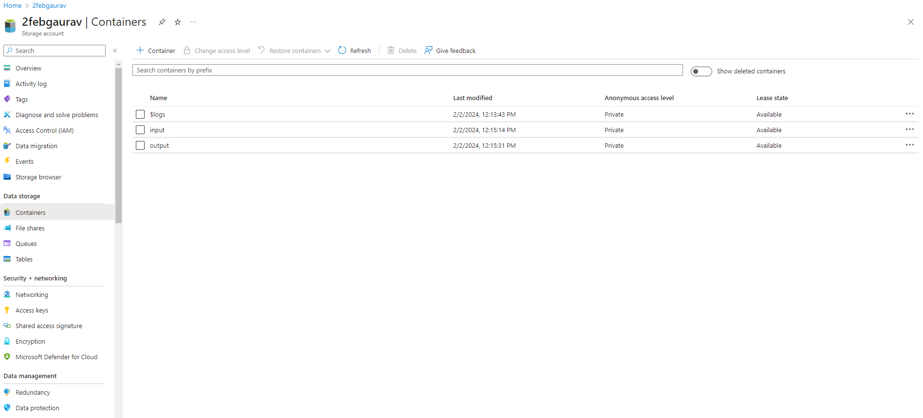

1. **Input container**

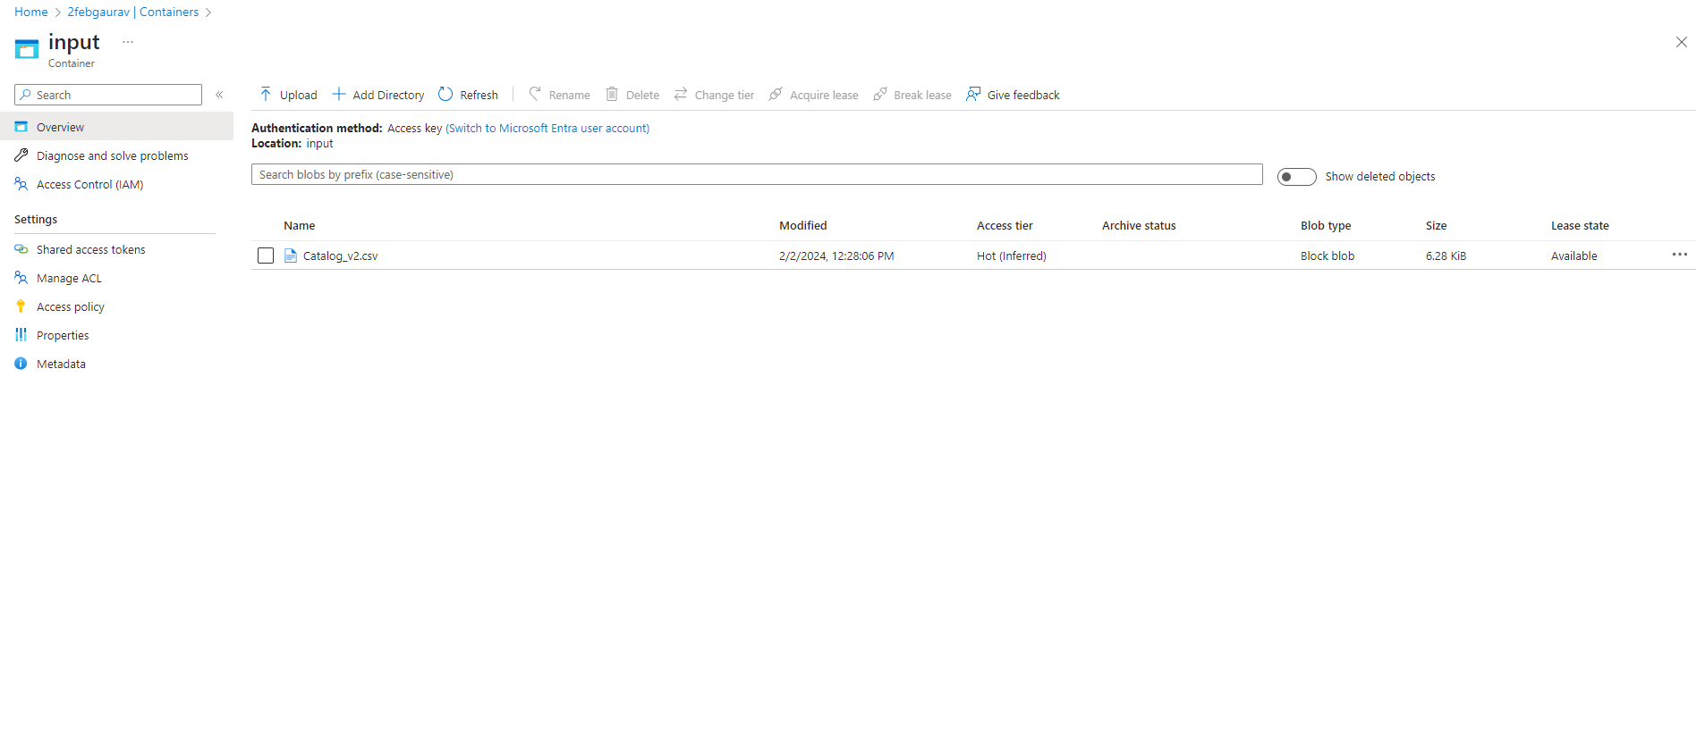

1. **Data factory**

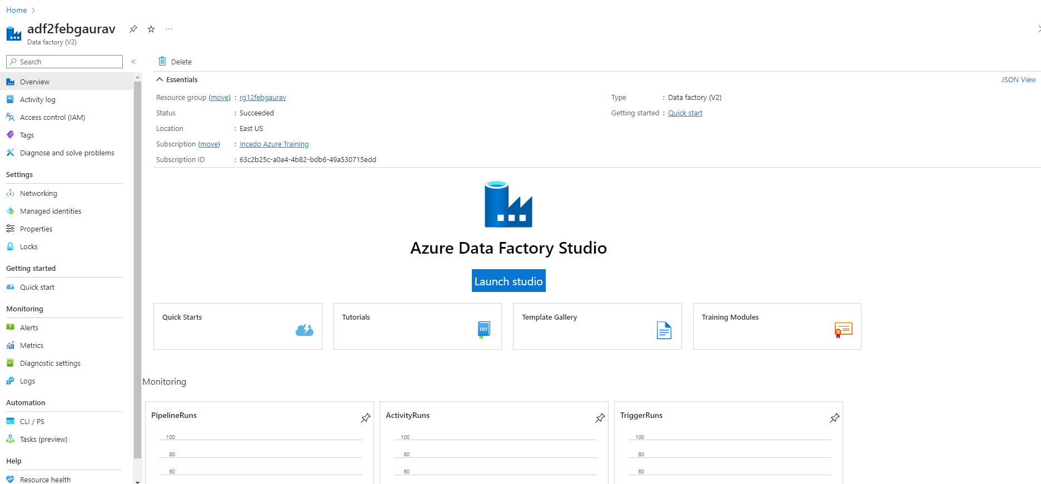

1. **Linked service**

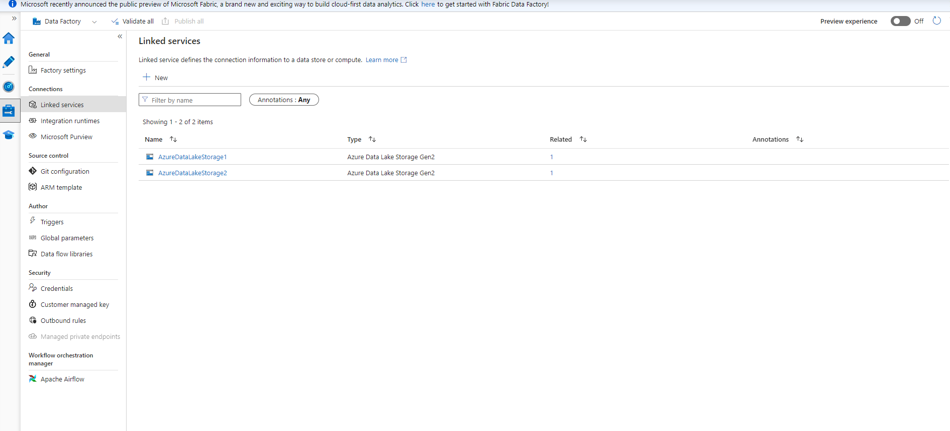

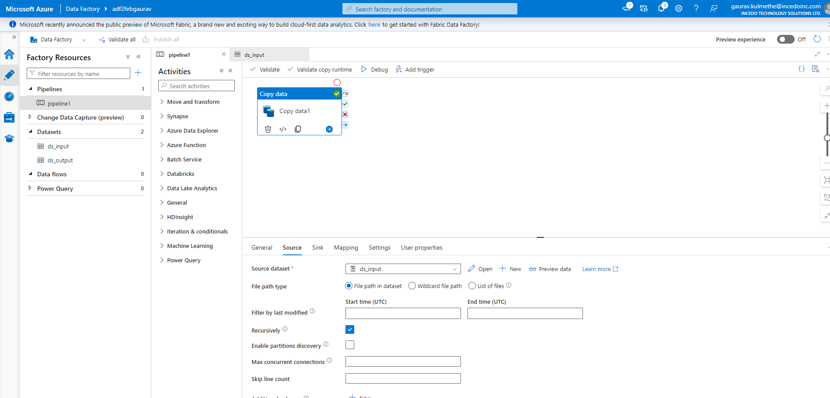

1. **Sink path**

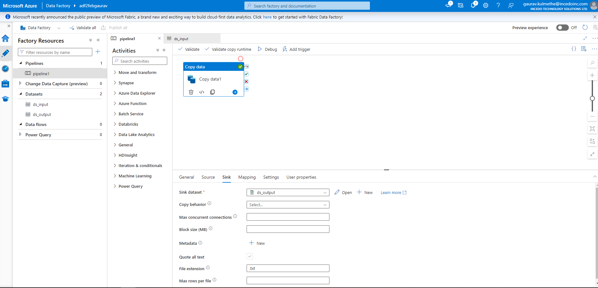

1. **Dsinput**

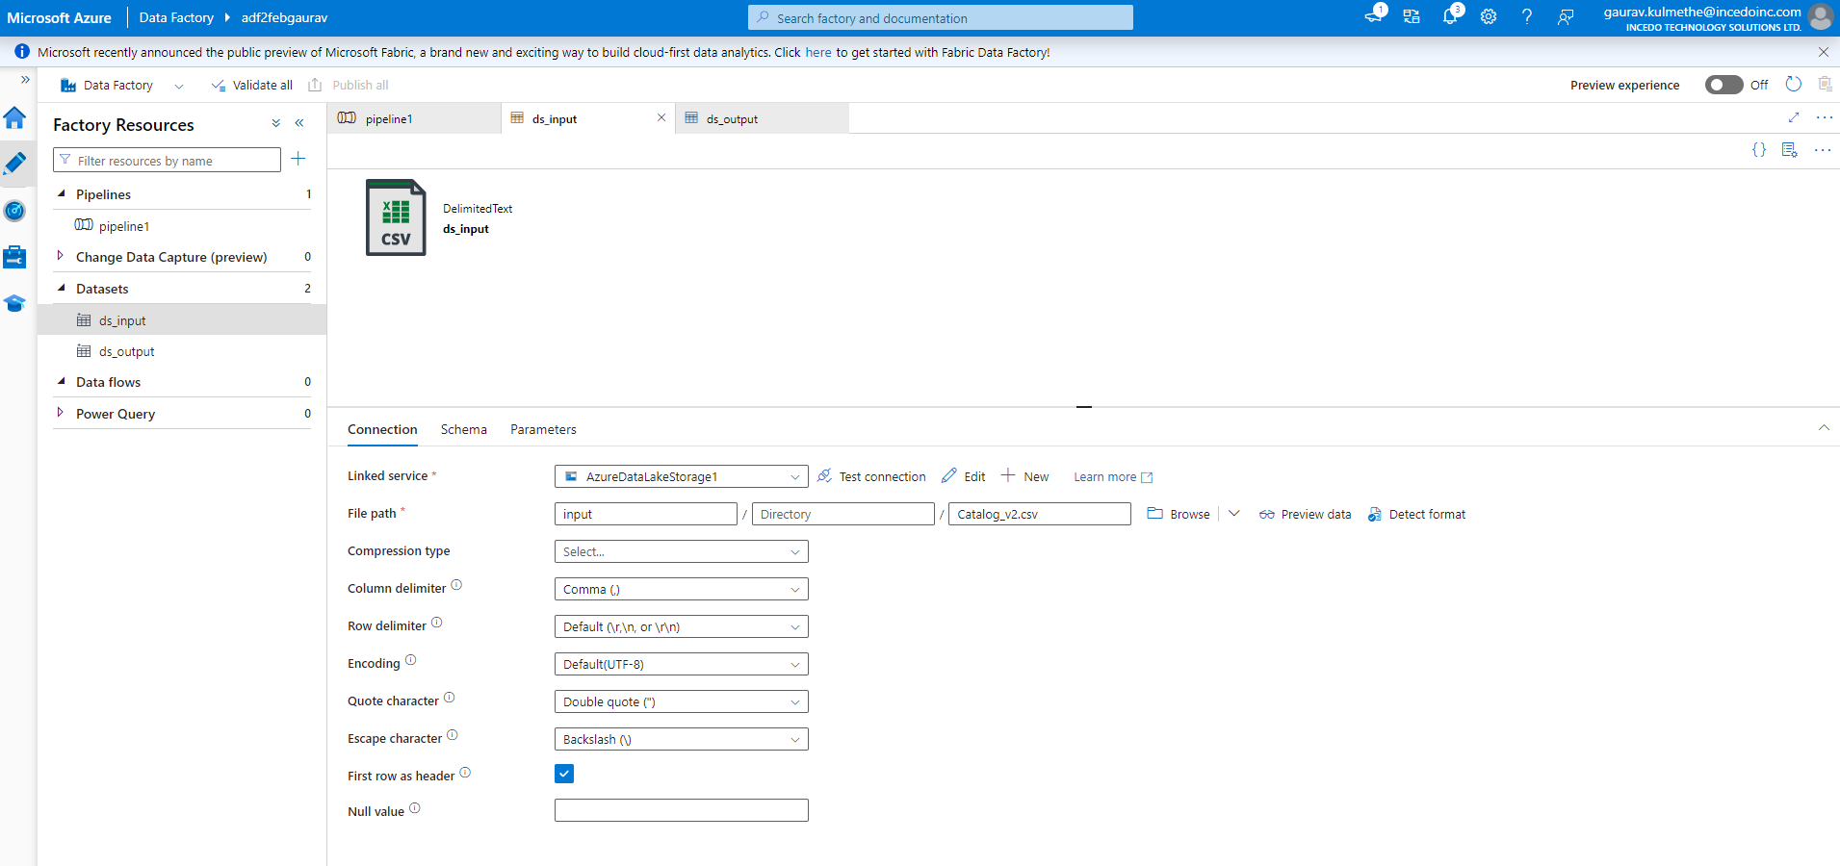

1. **Dsoutput**

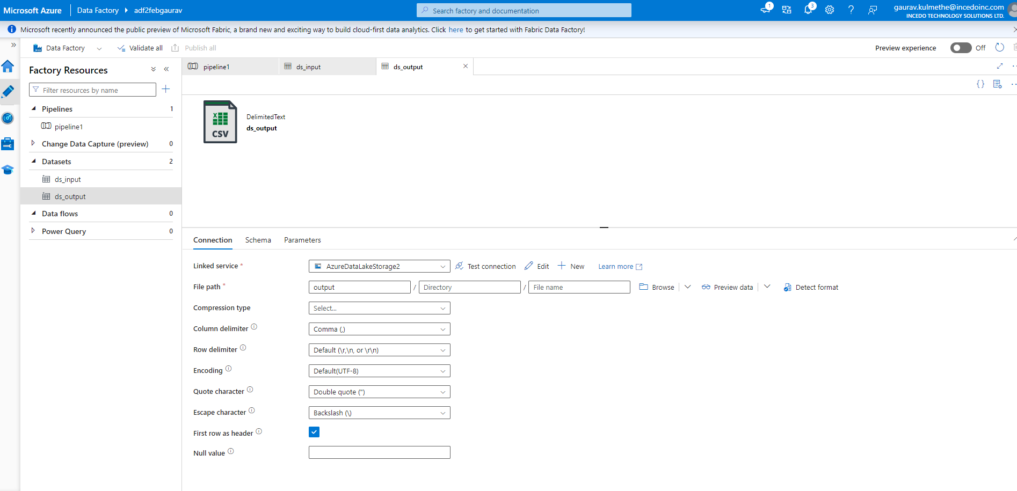

1. **Output container**

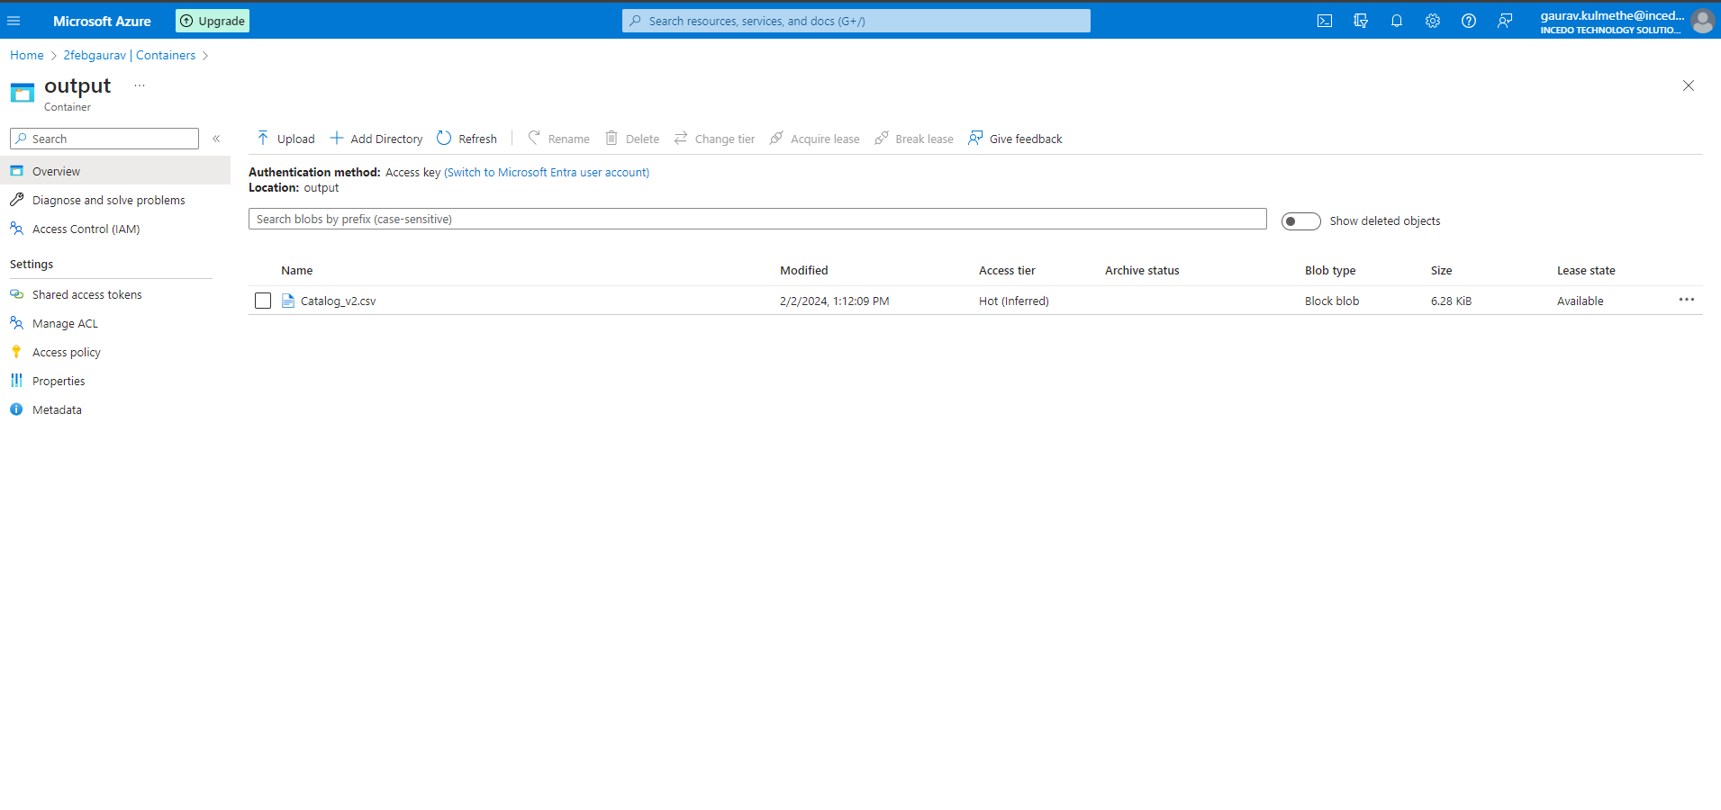

**Copy data from Azure Blob storage to a database in Azure SQL Database by using Azure Data Factory**

1. **Run SQL Query to create table in the Database**

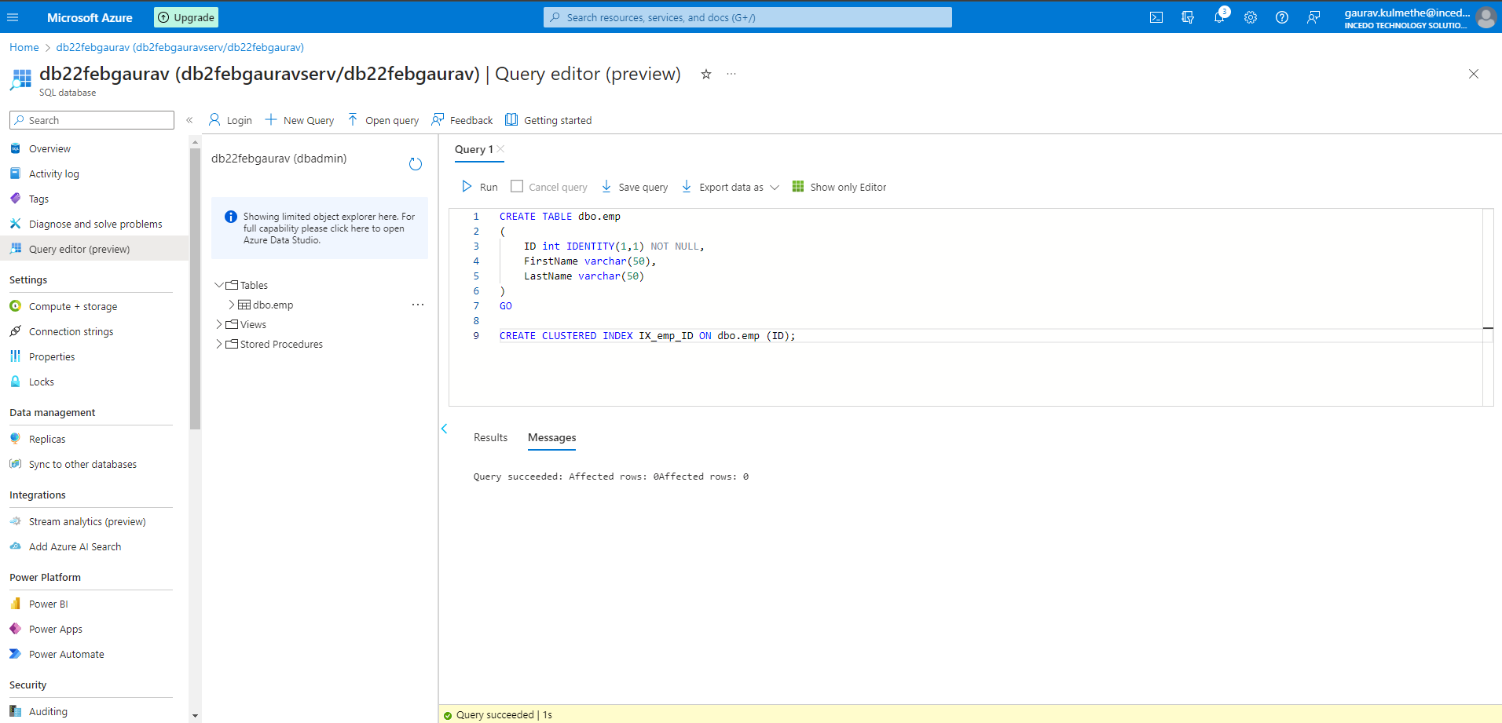

1. **Resource Group**

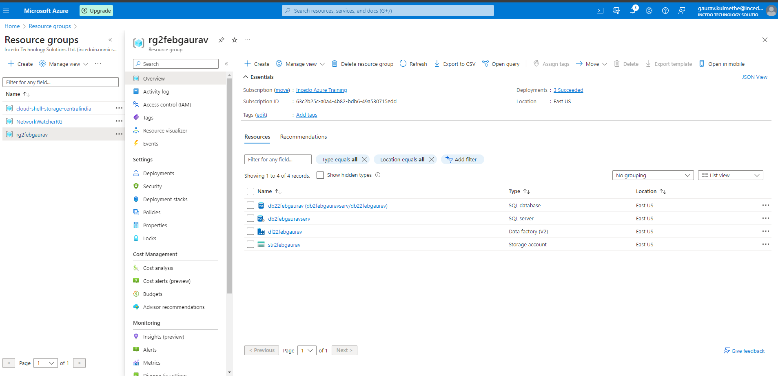

1. **Storage account**

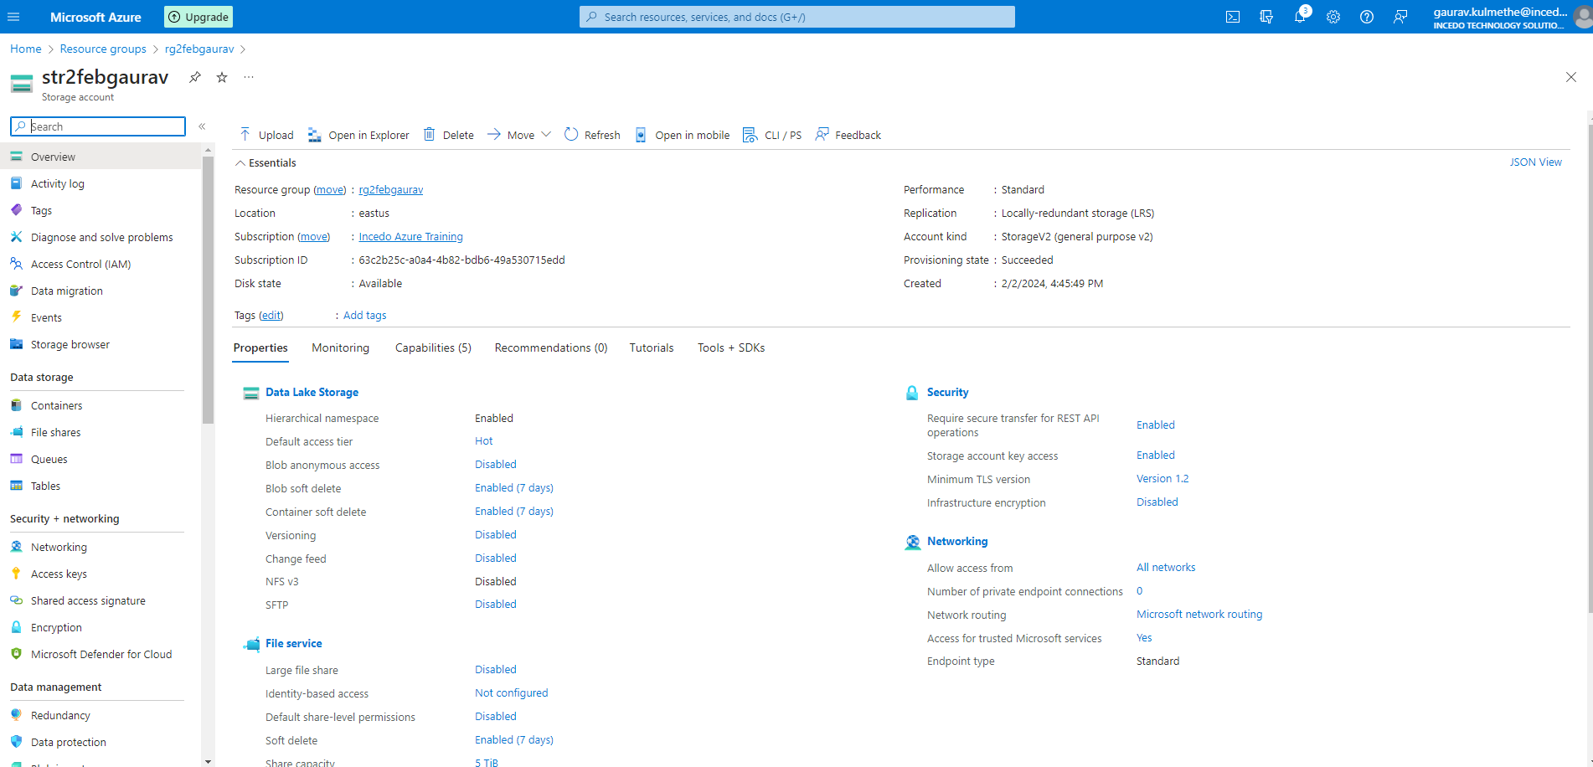

1. **Database server**

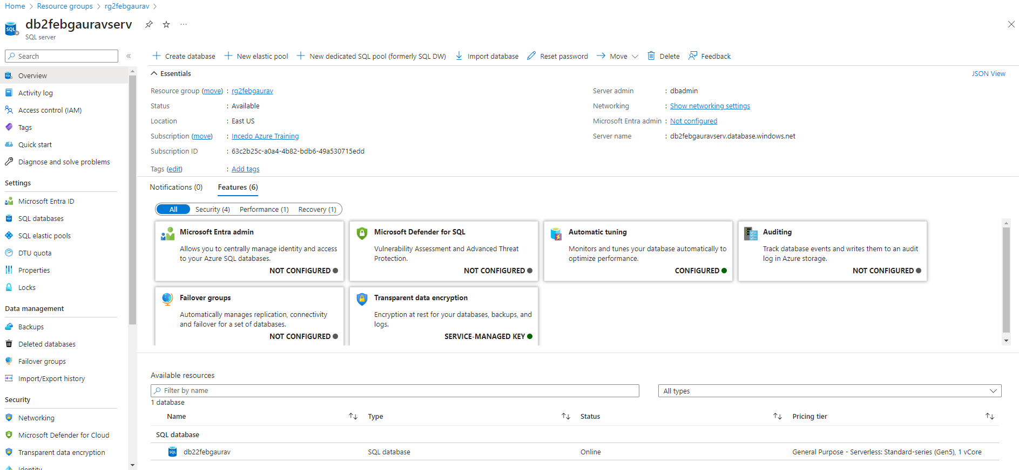

1. **Database**

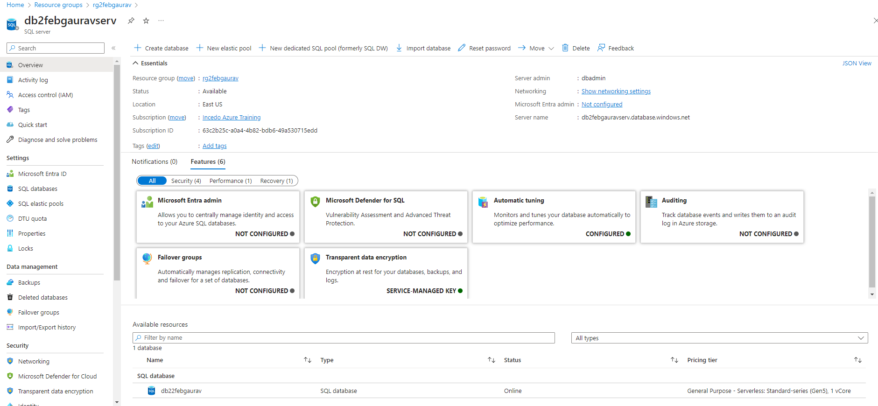

1. **Datafactory dashboard**

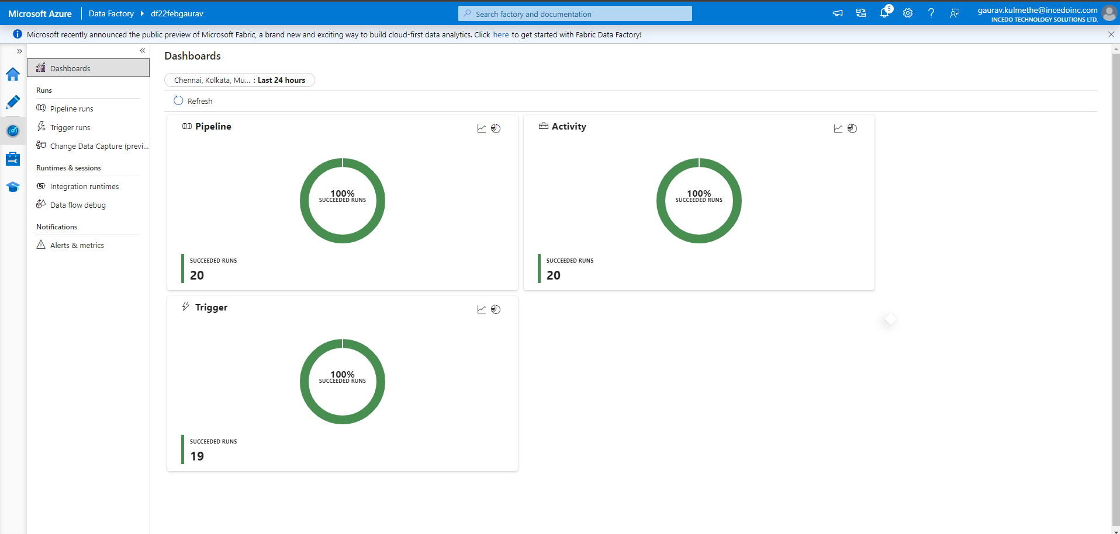

1. **Triggered runs**

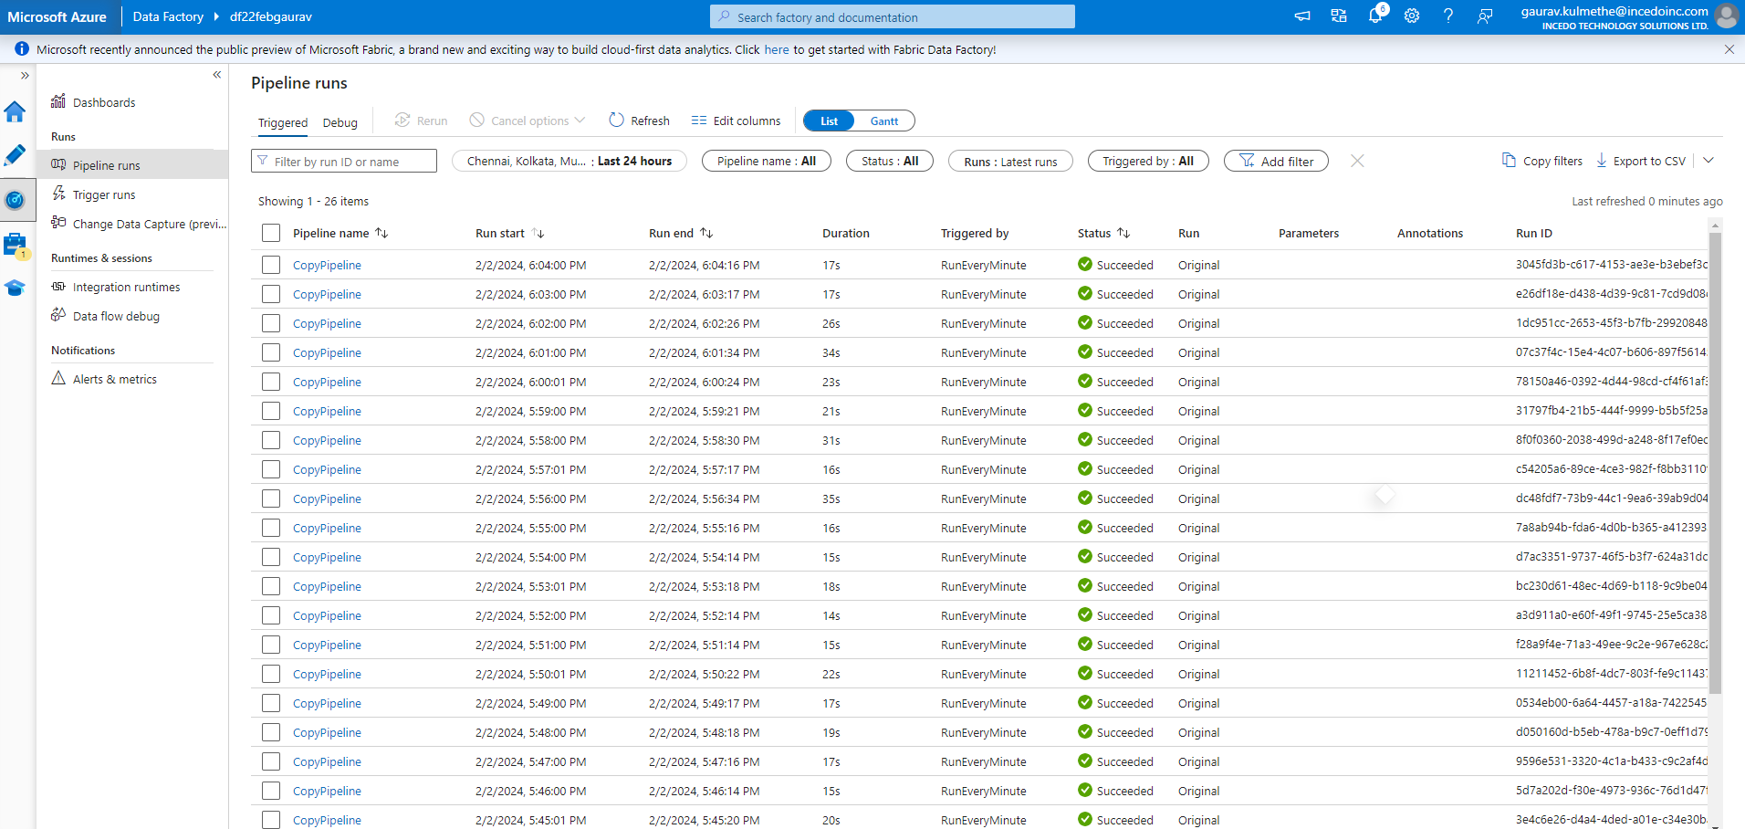

1. **Debug**

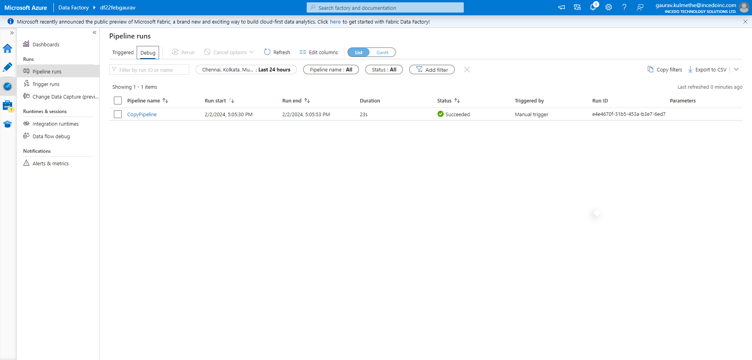

1. **Linked services**

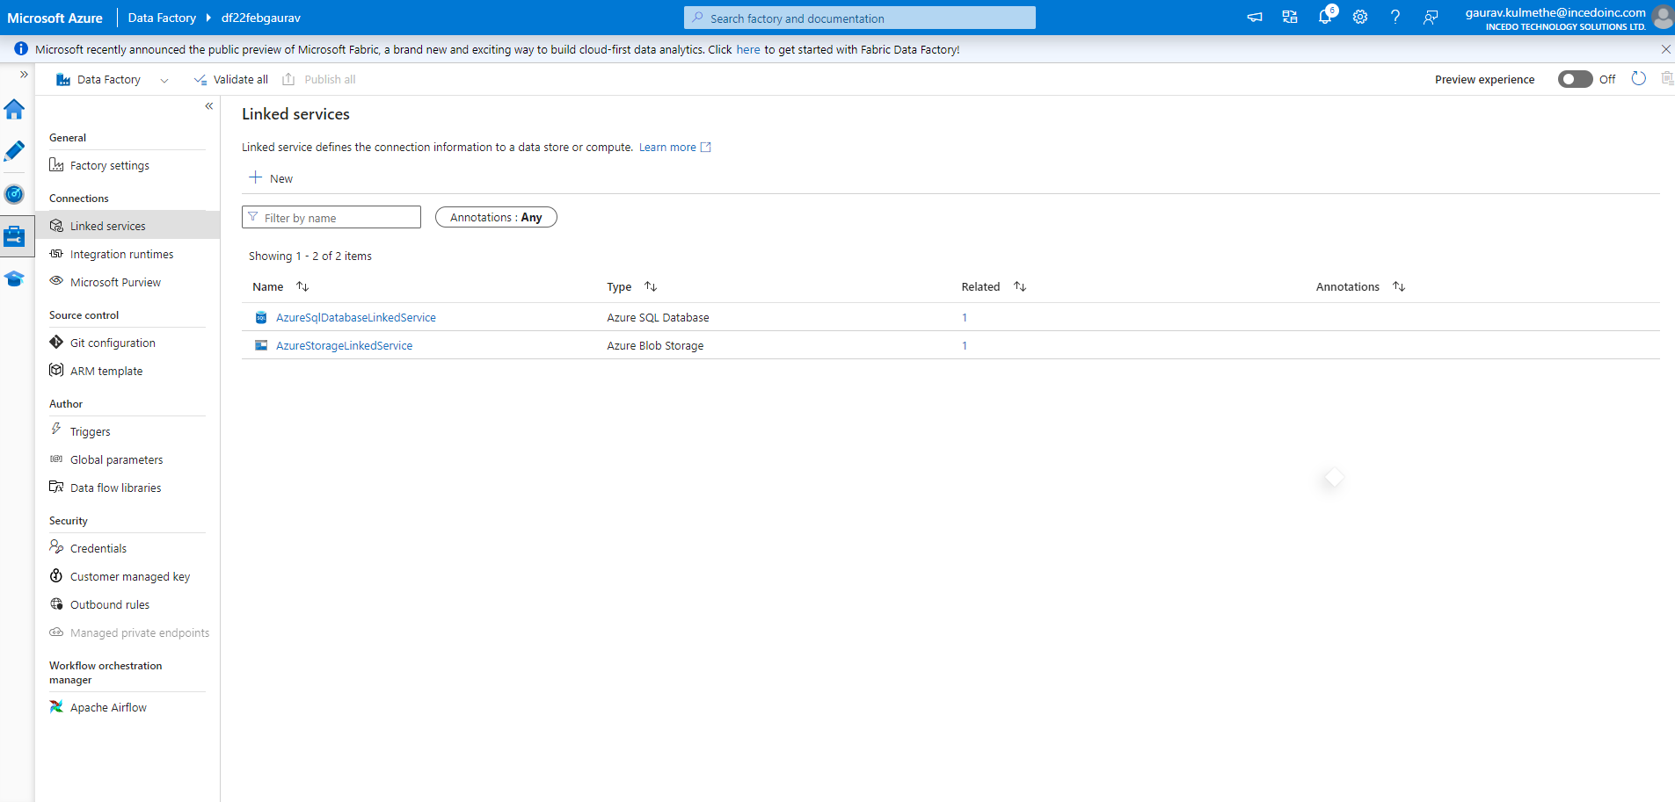

1. **Output SQL Dataset**

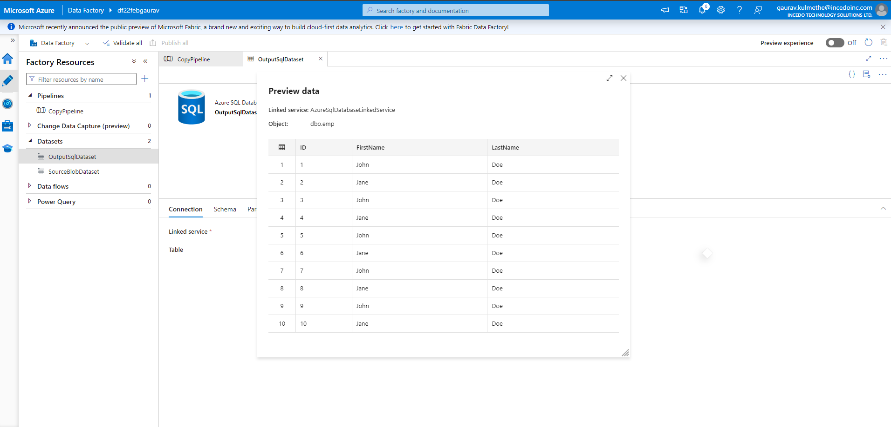

1. **Sourceblobdatasets**

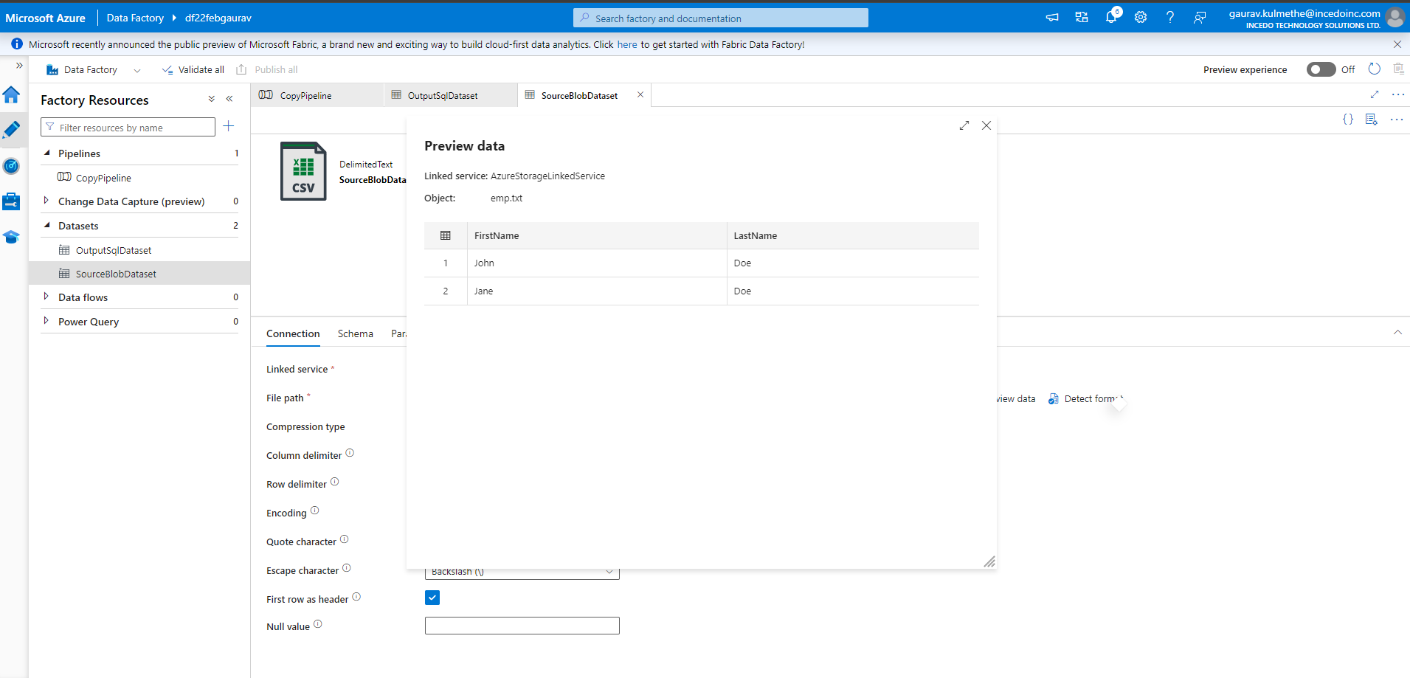

**Vnet to Vnet Connection dt.04-02-2024**

